Councillor Gary Norman
Mayor of Newbury
2022 – 2023
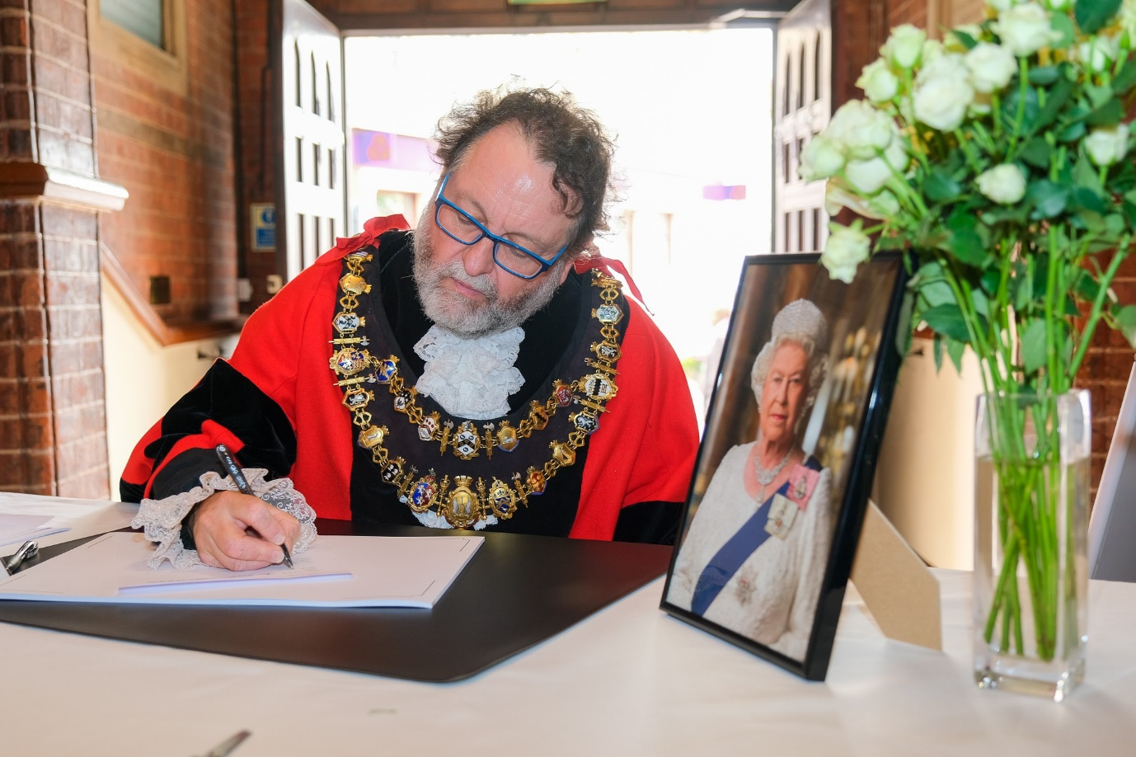

Official Record of Year in Office
15th May 2022 – 14th May 2023
Date of Mayor Making: 15th May 2022

Deputy Mayor: Cllr Nigel Foot
Mayoress: Sabrina Chetcuti
Chaplain: Rev Gary Collins
Cadets: Rose Clarke and Tomoya Burton
Civic Manager: Elisa Mullen

Civic Staff
Mayor’s Attendant – Ian Campbell
Town Crier – Brian Sylvester
Town Marshal – Barry Digby
Mace Bearer – Garry Poulson
Mace Bearer – Anthony Hewitt
Keeper of the Robes – Joyce Lewis

Mayor’s Chosen Charities
Speakability
Eight Bells for Mental Health

A Taste of the Civic Year 2022 / 2023

It seems only yesterday that I attended the ceremony where I became Mayor. Similarly with everyone who has ever become Mayor, the time seems to have gone very quickly, but when I look at the events that I have attended in my time in office, I can say that it has been remarkable.
Royal Events
Most Mayor’s terms pass without any royal events happening, but I have been honoured to have been in office at a time of major royal changes.
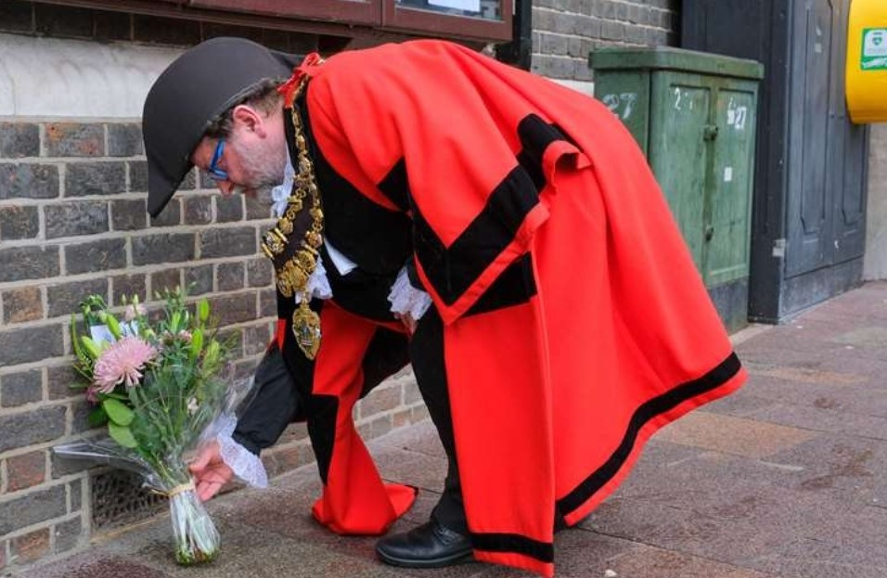
The year started with the Platinum Jubilee of Elizabeth II. A celebratory tree-planting ceremony at St Mary’s Church in Shaw was quickly followed by the beacon lighting ceremony in Victoria Park. This event brought home to me what it meant to be Mayor as it took me an hour to make a half-circuit of the boating pond in order to get to the stage; such was the clamour for photographs.
Contrast this with the sad death of Her Majesty in September, an event which bestowed upon me the honour of having to perform more solemn duties. The ceremonial first signing of the book of condolence, the laying (and ceremonial removing) of the memorial flowers in the Market Place, hosting much of the public signing of the condolence book, attending two memorial services to her majesty at St John’s and St Nicholas churches and assisting at the planting of a memorial tree on Stroud Green, all formed part of the duties.
This all led to the Proclamation of the new king in the Market Place. A hastily-arranged affair where I was asked to deliver the main speech. This was by far the most nerve-wracking event of my year but seemed to go off successfully judging by the feedback I received, mostly from strangers. Thanks are due to CEO Hugh Peacocke and to Councillor Tony Vickers for their feedback when reviewing my speech.
At time of writing, I anticipate the Coronation weekend, a fitting end to my year in office, where I shall be attending school visits, celebratory lunches and as many street parties as I can get to.
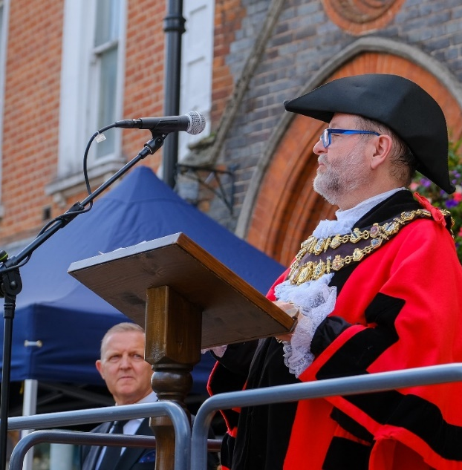
The only royal visit to Newbury this year was by HRH the Duchess of Gloucester when she came to Shaw House to open the Knowledge Event arranged by the Volunteer Centre. I was given the honour of being part of the welcoming party.
Military
The long-established relationship with the local military institutions has continued throughout the year. I have been invited to the Change of Command ceremony at RAF Welford for Major Smith of the USAF, inspections at both the Sea Cadets and Air Cadets in Newbury and two Armed Forces briefings at Sandhurst Military Academy.
I have also been invited to lay wreaths for remembrance events at RAF Welford (Remembrance weekend and the 101 Squadron Memorial), Greenham Common Control Tower (U.S. Personnel Memorial), Royal British Legion (HMS Tigris) and at the War Memorial in town on November 11th.
By far the most moving event of my year was the splendid Remembrance Sunday Parade in Newbury Market Place. Being asked to take the salute as the groups paraded past was one of the biggest honours of my life, especially as I was able to wear the war medals of my father (Korea) and grandfather (Somme). Special thanks to the Royal British Legion and to the Newbury Town Council officers for all the hard work to bring this about.
Senior Citizens
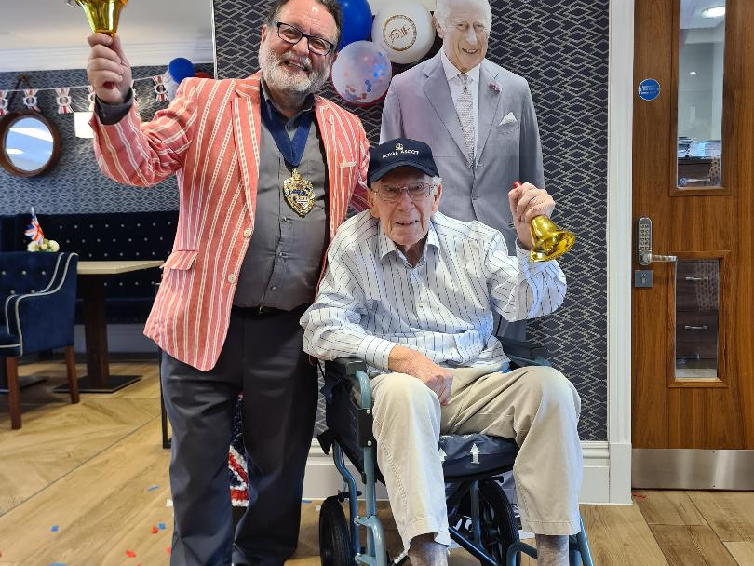
I have been invited to many events this year by communities of senior citizens. Older people are a joy to be with as they have a great respect for the position of Mayor and are always delighted and honoured to be visited. That feeling has always been mutual on my part. I was especially honoured to be invited to the 100th Birthday Party of resident Winnie at Winchcombe Place and of John Boulter at Hanover Meads. I have also been welcomed at Falkland Grange and the Argyles, and the lovely members at the Fairclose Centre have now become old friends. I was delighted to welcome many over-75’s to the Christmas Festive afternoon Tea in December which is now becoming an established annual event. I also had great fun in supporting the over-80’s Christmas parcel project run by the Newbury Weekly News and Sainsbury’s, where I assisted in packing and delivering the parcels. It was great fun seeing the surprise and delight on people’s faces when they open their door to the Mayor holding a parcel for them.
Children
Young children are the other group of people most appreciative of the Mayor. The looks of amazement on their faces, when I make my grand entrance during the primary school visits to the Town Hall during our Local Democracy Programme are a sight to behold, and the questions they ask are always surprising and challenging. I have been variously mistaken for the Queen and the King by the very young, but my favourite was a 5-year-old at Fir Tree School who thought I was Mr Tumble.
Local Education
I have been invited to attend many events at schools and colleges throughout the year and I am always happy to accept the invitations. The wonderful Castle School invited me to Photography and Art exhibitions. I presented awards in Engineering and attended “Destination Expo” at Newbury College. I presented achievement awards at the iCollege. I presented KS4 and KS5 awards at St Bart’s. I also attended the marvellous West Berkshire School Maestros concert in Basingstoke where all the Newbury primary schools took part. I have been no stranger to Trinity School all year and have attended art exhibitions, and the three house evenings of arts, dance and performing arts. I also had the pleasure of supporting Trinity at their victory in the School Mock Trials heat at Reading Crown Court; supporting at the final on 13th May will be my last duty as Mayor.
Charities
My two Mayor’s Charities for this year have been Eight Bells for Mental Health, a local support group for adults with mental health issues, and Newbury Speakability, a local stroke survivors’ charity. Both organisations have been working closely with the officers at Newbury Town Council in order to raise funds using their own members and volunteers with backup support and resources from the Mayor’s office. Speakability fundraising events that I have attended include coffee mornings, a town-centre walk and a bowls event generously laid on by the West Berkshire Indoor Bowls Club. Similarly, I have attended events laid on by Eight Bells including coffee mornings, street collections and a delightful Christmas concert arranged at St John’s church. In addition, Councillor Martin Colston and three of his friends from Newbury Velo were waved off from Friends Meeting House by myself and the Eight Bells members in order to endure a 24-hour marathon cycle ride to raise a substantial amount for the charity. Gloriously mad but heroic. Both charities also received donations collected at various Newbury Town Council events throughout the year including the retirement collection at the Civic Carol Service.
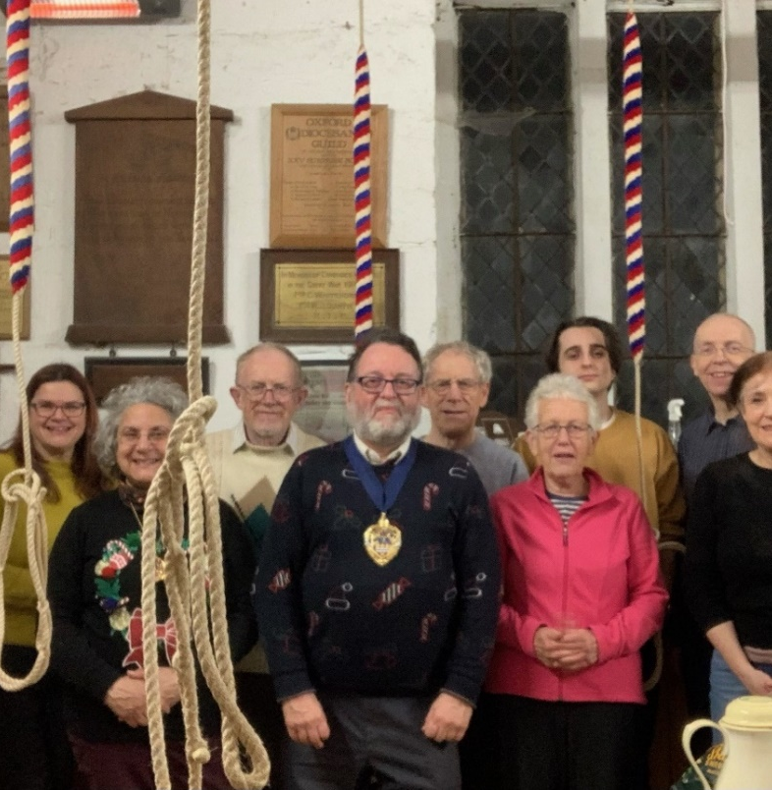
I have had the honour and privilege of working with and supporting many other local charities throughout the year. I have given out awards, attended AGM’s and open days, posed for publicity photographs and made speeches. Charities include Educafe, the Community Furniture Project, Rank-and-File refugee group, fibromyalgia support group, Berkshire Vision, Samaritans, Starts-at-Home at Bramlings House, HomeStart, WDP West Berkshire Drug Support, Forget-Me-Not society, Loose Ends, Newbury Soup Kitchen and Project Salama. I have also been involved with, and become an honorary member of, the Rotary Club and took part in their Boules in the Square event. I have supported Newbury Lions with their Santa Fun Run in the Market Place and was asked to do the countdown to the launch of the fireworks at the racecourse on Bonfire Night, where I had great fun warming up the crowd and generating some noise. Above all, I have worked on many events with Garry Poulson and the West Berkshire Volunteer Centre who provide essential support and advice to all the local charities.
Newbury is full of wonderful organisers and volunteers who go about their business of serving others quietly and without reward or recognition. The biggest delight of being Mayor is that you get to meet them and let them know they are appreciated.

Diversity
I let it be known at Mayor-making that I wanted to be Mayor for everybody, and invited diverse communities to contact me and ask me to their celebrations. I have had a fantastic and enthusiastic response. I have celebrated Pongal with the Newbury Tamil School and made presentations at their annual awards. I have celebrated Onam with the Malayalee community and Diwali with the Telugu community. I enjoyed a Taste of Ramadan and an Ishtar celebration at the Muslim Centre in Clay Hill as well as Eid prayers and a celebration barbecue with the Newbury Mosque in Pound Street. Every community has treated me with great honour and hospitality and all have been a delight to visit. Colour, costume, singing, dancing, wonderful food, the list goes on.
I have worked with the Baharati Shaktar (SEWA) Hindu charity on several occasions and attended their fascinating “Celebration of the Teacher” evening. They asked me to suggest a local charity to which they could donate some children’s toys for Christmas. I put them in touch with HomeStart who deal with young families with children. The two charities worked together to make sure all the children got exactly the toy they most wanted.
I was honoured to have been asked to open the “50 Years Ago” exhibition at the Greenham Control Tower. This was to commemorate the arrival of the Asians expelled from Uganda by Idi Amin, many of whom were housed at Greenham Common. The Ugandan Asians group subsequently invited myself and my wife to a marvellous dinner to celebrate.
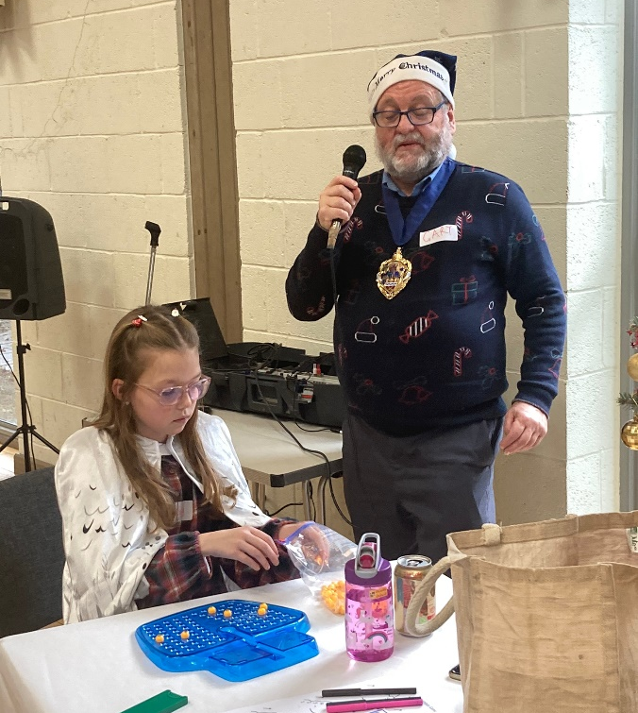
Thanks must also go to Community United who provided much of the communication and support to enable me to get involved with all the groups. I attended their Charity Cricket Match in the summer and was delighted to see most of the ethnic communities involved, and the local asylum seekers providing the stewarding.
I have also been able to meet many of our local Ukrainian guests throughout the year as we continue to welcome them to the town.
I know that future Mayors will continue to reach out in this way and shine a light on these communities.
LGBTQ+
Continuing the theme of inclusion, I have been involved with the local LGBTQ+ on several occasions this year. I attended the Pride Parade in Reading with a whole chain-gang of Mayors, and the historic first Pride Parade in Newbury where the video of me dancing with the Rev Gary Collins went viral (Thanks to the Deputy Mayor for filming that). I also attended the very moving Trans-memorial day celebration in Reading where I gained much insight into the problems that trans people face.
Openings
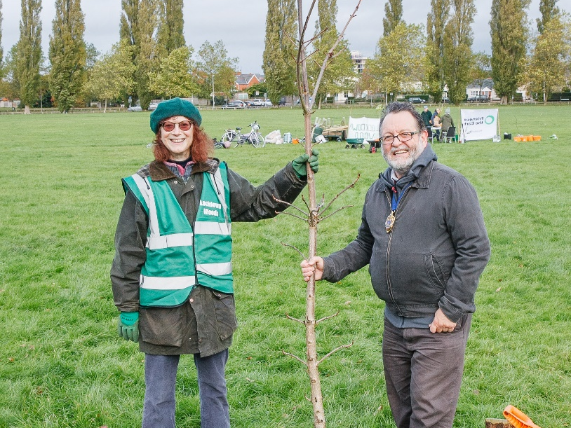
I have been invited to many launch events during the year; these include two new retail businesses in the town, the Kennet and Avon Canal Waterways Festival, the launch of the Newbury Festival Open Studios and the official opening of the Waterside Centre for Berkshire Youth. In particular, the latter gave me much pleasure as much of the event was organised by the young people themselves and they did a great job.
Council Activities
Part of the duties of all Mayors is to support the civic activities arranged by the officers of the council, either directly or in collaboration with other organisations. This year has been no exception with all the following events: opening the new disabled see-saw in Victoria Park, opening the refurbished children’s playground in Fifth Road and providing a photo-op of me squeezed into the kids’ slide, unveiling three new blue plaques in the town, helping to plant the new flowerbed for Ukraine on the Wharf, presenting the allotment awards, hosting the Heritage Open Day at the Town Hall, and judging and presenting the prestigious Civic Awards.
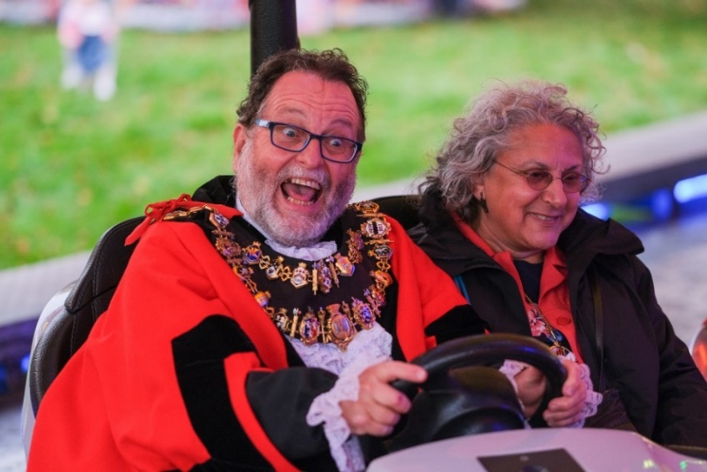
I was also asked to open the Michaelmas Fair by the Showman’s Guild which was a delight and resulted in the best newspaper picture of the year for me, having fun alongside my wife on the dodgems. They also gifted me a cheque for my charities and a large pink fluffy wasp that now sits in the Mayor’s parlour.
We also worked with the Newbury Twin Towns association on three different occasions, hosting a coffee morning, a visit from young people of seven countries as part of Youth for Europe and a visit of school students from Eeklo.
The Friends of Newtown Road Cemetery were not neglected either as I attended their Open Evening as well as opening their new composting toilet.
I worked with the BID on several occasions, most notably on the Christmas Light Switch-On where I shared the stage with Snow White, Elsa from Frozen and Father Christmas.
The Family Fun Day in the Victoria Park was a great success with lovely weather. A photograph of me queueing up for ice-cream in my official robes went viral.
The official Newbury Civic Carol Service was reintroduced this year, conducted by the Mayor’s chaplain at St John’s church. The highlight was one of the readings, given by Jenny, an aphasic stroke survivor from Speakability, for whom it was a major achievement.
The most bizarre event of the year came when Newbury was named as the latest town to be granted its own Monopoly set. A publicity photo event involving the town crier, Mr Monopoly and myself made the front page of the local paper.
Other Official Duties
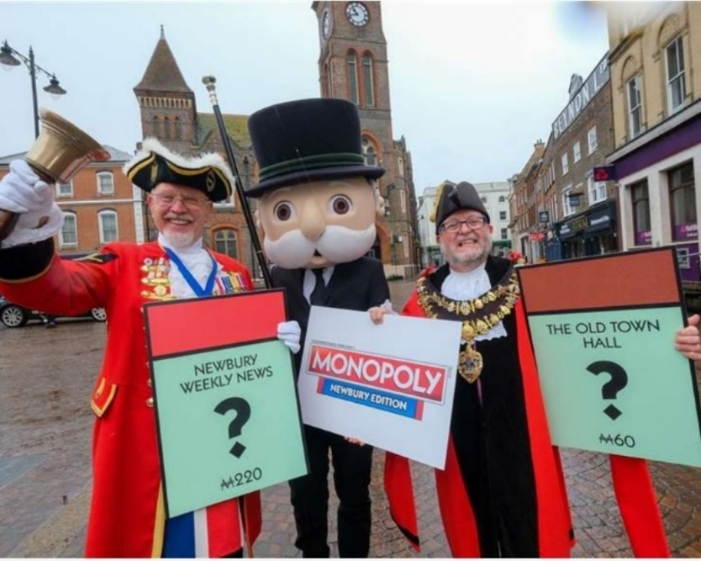
I have been invited to represent the town at countless other official functions including: the AGM of the West Berkshire Heritage Forum; the Lord Lieutenant’s Garden Party at Welford Park and his annual cadet awards at Sandhurst; the amazing Abbatial Blessing of the new abbot at Douai Abbey; the 25th anniversary celebration of the incomparable Greenham Trust; the start of the second leg of the annual Devizes to Westminster canoe race; three events for the Newbury United Nations Association, including the Holocaust Memorial Service hosted at West Berkshire Council; finally, no less than 5 Carol Services in addition to our own (including two on the same day).
Kind Invitations
I have also been kindly invited and entertained at all sorts of events throughout the year including the Newbury Symphony Orchestra, a canal boat trip with the Newbury Society, Voxfresh and other concerts at Arlington Arts, the York Nativity play at the stunning Church of St Mary the Virgin in Aldermaston and the Civic Reception given by the Mayor of Thatcham. On every occasion, I get the best seat in the house and the VIP treatment.
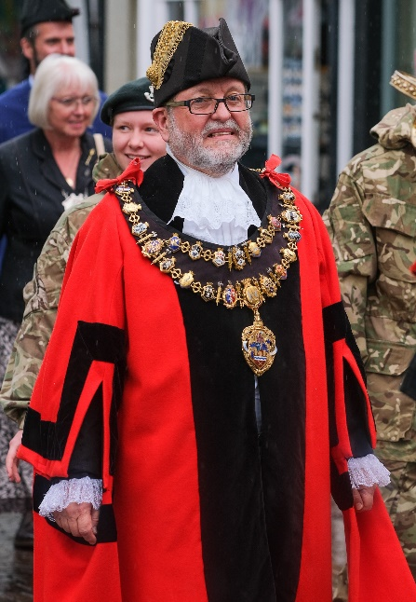
In Conclusion
I would like to thank my wife and Lady Mayoress, Sabrina Chetcuti, for sharing much of this journey with me this year. I was also like to thank all my attendants Joyce Lewis, Brian Sylvester, Barry Digby and especially Ian Campbell, the main man, whose experience with 14 previous Mayors has been an invaluable asset. Also thanks to Elisa Mullen, the tireless Civic Manger and to Suzie, Amy and Virginia who have all had to stand in at some stage.
Thanks also go to Jeff Brooks, Mayor of Thatcham, Rick Jones, Chair of WBC and Helen Simpson, Mayor of Hungerford, whose frequent company this year has always been a delight.
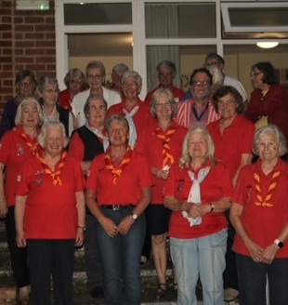
Finally, I would like to thank all the people of Newbury that I have had the pleasure of meeting this year for making my year so special. I started off at Mayor Making by saying how much I love Newbury only to find that, at the end, I love it more.
To quote the king: “I came here not to be served but to serve”. This also applies to the office of Mayor, but it doesn’t mean that service can’t be the best year of your life.

Newbury Town Council recorded its Thanks to
Councillor Gary Norman
on behalf of the people of Newbury in recognition of his
Year in Office at Town Mayor
15th May 2022 to 14th May 2023

Present when the Seal of
Newbury Town Council
was affixed

Deputy Leader of the Council: Jo Day
CEO of Newbury Town Council: Hugh Peacocke
Dated 14th May 2023
Town Mayor’s Report to Full Council
27th June 2022

18th May – Youth in Mind Conference, Reading
The conference, discussing mental health in young people, was jointly presented by MIND (Berkshire and Oxfordshire) and by Berkshire Youth, with our friend Dave Seward taking a prominent part. I attended several sessions, mostly in the company of Garry Poulson, and managed to network with many local support organisations including Time to talk, No. 5, Samaritans, Kooth and Get Berkshire Active. Some or all of these may be able to contribute to any youth initiatives we come up with in the future. Literature on all of these is now held at the town hall for anyone interested.
22nd May – Memorial Tree Dedication, St. Mary’s, Shaw
Three cherry trees were planted and dedicated to (a) the 75th anniversary of VE Day, (b) the memory of those who suffered because of Covid-19 and (c) the celebration of the Platinum Jubilee. I was asked to plant the plaque for the latter. This was followed by Evensong and then tea and cake in the church hall. Spoke to everyone there and was given warm wishes for my Mayoral year.
25th May – Tour of the Corn Exchange
I was given a private tour of the Corn Exchange along with the Lady Mayoress and the Civic Manager. I was particularly impressed by the technical space behind the stage and by the tiny cinema up in the rafters behind the skylight in the top of the façade. I was invited to attend the memory café for a few minutes. The café is designed to stimulate the minds of people who are experiencing various forms of dementia. I took part in some music therapy where I was asked to perform a solo on some chime bars whilst sitting at a table with the cafe guests. Smiles and laughter followed, I can’t think why.
26th May – Change of Command, RAF Welford
I was invited, with other local civic functionaries, to attend the change-of-command of the base for the US 420th Munitions Squadron, to Major Preston G Smith. It was a fascinating ceremony with speeches and prayers and quite a lot of shouting. Apparently, they look after in excess of 8,000 “pineapples” at the base. None were featured in the refreshments, however, which consisted entirely of cake, which is becoming a theme.
2nd June – Jubilee Party, Fairclose Day Centre
I attended the Fairclose Day Centre for over three hours with the Lady Mayoress and the Mayor’s Attendant (or “Chain Attendant” as it said on his placename, which he thought sounded slightly lavatorial). We had a fantastic time where we were entertained by a steel band as well as by Winston Churchill and Lady Churchill lookalikes. The refreshments were excellent (especially the cakes). I managed to speak to everyone there, all of which were wonderfully impressed with Fairclose and what they do. I was also asked to judge the best hat. A bit of a thankless task this, as after I made my decision, at least two people wanted
me to explain why they didn’t win. Resolved to delegate judging decisions to the Deputy Mayor in future.
2nd June – Jubilee Beacon Lighting Ceremony, Victoria Park
A wonderful event and much credit should go to the entire civic team, but especially to Elisa, and to Brendon who braved the pond in order to light the beacon. I spent much of my time posing for photographs and handing out pin badges. Indeed, it took me more than an hour to walk half-way round the pond. My speech seems to have gone down well as I received an email from a member of the public saying they liked the tone and balance of it, which is encouraging. I felt uncomfortable being so much in the spotlight whilst my fellow councillors were mostly picking up litter. However, I will be there on litter duty next year for civic events. Also, the local sea cadets managed to collect a lot of money for the Mayor’s charities.
3rd June – Jubilee Party, Winchcombe Place Care Home
I attended this with the Lady Mayoress. Spent the time sitting (and dancing) with the residents and joining in with the entertainer singing wartime songs. Cake was particularly good.
6th June – Jubilee Party, Newbury Speakability
I attended the Speakability Monday morning meeting in full robes and chain with the attendant and the Lady Mayoress. My thanks to Barry for stepping in as attendant for the day so this could happen, and for going around the room speaking to all of the members. Got some delightful feedback from the members who were made to feel very special by the event.
6th June – Castle School Photographic Exhibition, WBCH
Unveiled a photographic exhibition at WBCH, the work of Dover Class at the Castle School for Students with a variety of learning difficulties. This was the culmination of some fantastic work organised by the Thatcham Photographic Society, particularly Ray Buckland, working with the kids. I handed out certificates to each of the kids individually and discussed each of their photos with them. After group photos with the class, we all went home happy.
7th June – Armed Forces Briefing, Sandhurst Military Academy
The briefing was for local civic leaders in Berkshire and Surrey. The Mayor of Thatcham and of Hungerford were also in attendance. We were briefed on the roles of the Army locally with special emphasis on the reserves and on cadets. Everyone in the room was either in uniform or wearing a pendant or chain. Made several useful contacts which the Town Council may find helpful in the future.
9th June – Primary Schools’ Production “What Makes a Town?”, Trinity School
I was invited to attend a performance about Newbury arranged by the Watermill Theatre Outreach department. Four individual plays were performed by Whitelands Park, Speenhamland, Robert Sandilands and Firtree. They were all a genuine delight and included a scene in the last play where the Mayor of Newbury flanked by his Deputy and Deputy’s deputy came out with such catchphrases as “Don’t you know how important I am?” and “I’m the Mayor of the best town in Berkshire”. I don’t intend to adopt these
phrases, but I did enjoy meeting the three kids for a photograph afterwards.
11th June – SEWA Indian Charity Coffee Morning, Town Hall
I have never seen such a large crowd for a coffee morning in the town hall, nor such a variety of ages from children to elderly. A large percentage were from the Indian Community but there were a significant amount of people there from other backgrounds. The home-made Indian food was fantastic and it was a delight to see such an inclusive event. The money raised went to the Castle school.
11th June – Interview with Kennet radio
I was interviewed for about 20 minutes on who I was and what the Mayor does, as well as being asked to select a track to play (which has always been an ambition of mine). I think I got across what we are trying to achieve and have had some good feedback since. The interview is still available on the Kennet Radio website.
12th June – Family Fun Day in Victoria Park
Thanks to the officers, especially Caroline and David, for all the work they put in to organise this event and to all the Councillors who volunteered to help out. I think it was a roaring success and we got great coverage in the NWN afterwards. I spent most of the day posing for photographs and making unprepared speeches, as well as presenting the prizes for the tennis competition and taking part in the Kennet Radio Yes/No game. The most common question I was asked was “Aren’t you hot?” and “Is that chain heavy?” Answer yes to both. The Deputy Mayor managed to get a photo of me queueing for ice-cream, which I’m sure will be used in the future. A small amount of money was raised for the Mayor’s Benevolent Fund.
13th June – Talk on “Long Covid” Organised by West Berkshire Fibromyalgia Support Group, Shaw House
I attended a talk on Long Covid where I learnt a lot of things in an hour that I had no idea about. I was asked to make a speech of thanks at the end for the main speaker Dr Dipak who presented a difficult and technical subject in an entertaining way without dumbing-down in any way. Main lesson: there is no correlation between the severity of symptoms suffered when contracting Covid and the severity of symptoms of Long Covid.
15th June – Visit to Ukrainian Support Group, Newbury Baptists’ Church
I visited the Ukrainian Refugee support group that meets every week at the Baptist Church, at the invitation of Gillian Durrant of Newbury Twin Towns. I spoke to a variety of Ukrainian people with various stories to tell. Without exception, they were all overwhelmed by the support they are receiving from their host families and by the warm welcome they have received from the town. One particular little boy was very impressed with the custard creams on offer. I gave them all the best wishes of Newbury town council and intend to go back in the future.
Cllr Gary Norman, Mayor of Newbury

Town Mayor’s Report to Full Council
30th January 2022
20th October – Performing Arts Evening at Trinity School
An enjoyable evening that consisted of each house presenting a music/dance/drama piece produced, written, directed and performed solely by the students. Very high standard.
21st October – UN Day Flag Raising on the Town Hall Steps
Joined Graham Panting and others of the local UNA on the steps to raise the UN flag. Made a short speech about how the UN is more relevant than ever in the current world situation.
29th October – Coffee Morning for Eight Bells in the Town Hall
Supported the coffee morning in the Town Hall for one of the official Mayor’s charities for this year.
29th October (Lunchtime/Afternoon) – Diwali Celebration
With the Telugu Community at the Phoenix Centre in Newtown Road. I was given the honour of opening the Diwali celebration by lighting the ceremonial lamp (which was ringed with a repurposed string of Christmas lights due to the fire regulations in the hall). The Telugu community come from the states of Andhra Pradesh, Telangana and Puducherry in the south west of India and are well represented in West Berkshire. They delayed the start of the celebration so that I could first attend the coffee morning, and they wouldn’t start without me. The celebration consisted of a programme of singing, dancing and poetry performed by groups and individuals of all ages, either side of a fantastic vegetarian meal. The traditional costumes were fantastic and were obviously a labour of love as it takes over an hour to dress each child.
30th October – Heritage Open Day at the Town Hall
After a slow start due to rain, the open day was a real success with many visitors seeing the Town Hall for the first time. I spent most of my time greeting guests in the Mayor’s parlour, posing for photographs and telling stories. There were a surprising number of visitors to Newbury, including many from overseas. The kids all enjoyed the cuddly toys and the gift badges.
2nd November – AGM for Loose Ends Charity at Newbury Cricket Club
Attended the AGM as a guest and representative of Newbury town council along with others. Good to see such a worthwhile homeless charity thriving in its new home. Proud of the support that Newbury town council has given them.
3rd November – Official Opening of the Waterside Centre with Berkshire Youth
A great event supporting, highlighting and celebrating the current and future success of Berkshire Youth. Attended alongside the local MP and Lord Benyon. I was asked to make a speech where I highlighted the bad press that young people get and how when treated with kindness and understanding they can shine. We saw many examples of fine young people and what they achieved during the evening, which was rounded off with a great set by the VoxFresh choir.
4th November – Memorial Service for Queen Elizabeth II at St Nic’s Church
A solemn and moving evening which should have been an honour and privilege to attend. Some of the official arrangements left a lot to be desired. Even the minister was embarrassed on our behalf. Received an official apology from WBC Chair Rick Jones afterwards, but he was not personally responsible.

5th November – Mayor’s Coffee Morning for NWN Over-80’s Fund
An official coffee morning in the Town Hall raising funds for the NWN over-80s Christmas parcel fund, speaking to visitors and posing for photographs with Jo Fulker of NWN.
5th November (Evening) - Countdown for the Racecourse Fireworks Display from Newbury Lions
Had great fun warming up the large crowd before initiating the countdown for the setting off of the fireworks. Julian Swift-Hook from Kennet radio drew the crowd’s attention to me dancing with my wife to the music on the gantry, which resulted in having to join some teenagers dancing in the crowd. A really good night.
9th November (Morning) – “Chai & Chat” with Project Salama at the Riverside Centre
A new charity set up to support victims of domestic abuse, especially in ethnic communities. (“Salama” being Swahili for “Safe”). Got good coverage in the NWN. Some moving stories from many of the attendees including men. I wish them every success.
9th November (Evening) – “Where do we go from here” by the Rank-and-File Group at South Street Arts
Theatre, Reading
A remarkable play performed by refugees, asylum seekers and other members of the community, using the metaphor of a railway station with arrivals, departures and a waiting room full of people with nowhere to go. Great question and answer session afterwards and had a good opportunity to talk to the refugees.
10th November – RAF Welford Remembrance Day Service
The first of four remembrance services. Laid a wreath on behalf of Newbury town council in the memorial garden at RAF Welford to commemorate lost British and American servicemen. As usual, Major Smith and the USAF were excellent hosts.
11th November – Wreath Laying at the town War Memorial
A short service and wreath-laying at the town war memorial at 11:00 on 11/11. Joined by some old soldiers which made it an honour to lay the wreath.
12th November – Interview with Kennet Radio
I was interviewed by Paul Walter of Kennet Radio about what Remembrance Sunday means to me and to explain the arrangements for the following day. Still available at:
https://kennet.redio.co/listen/again?date=Sat,%2012%20Nov%202022%2011:00:00%20GMT
13th November – Remembrance Sunday
The main event for Remembrance Sunday. I think taking the salute is the biggest honour the Mayor has in his year in office. I was warned in advance by Cllr Drummond about how emotional it is when hundreds of people march past and turn to salute you, and he wasn’t wrong. I was able to wear the medals of my late father (Korean War) and grandfather (Battle of the Somme) and felt very proud. As usual, the whole thing was beautifully arranged by the Newbury town council officers in association with the Royal British Legion. Being asked to read in the church service afterwards was also an honour. British Legion refreshments were as excellent and generous as ever.
19th November (8:00) – Table Tennis Marathon at Fairclose Centre
I was invited by Cllr Miller to open the Table Tennis Marathon at Fair Close Centre at 8:00 on a Saturday morning. I was impressed he managed to show up in support. Managed to take 6 points from the expert player which should mean £6 for the centre. Hadn’t played for 40 years. Was due to last for 24 hours so I hope it raised a lot of money.
19th November (10:00) – Launch of Day Festivities for Christmas Light Switch-On
Consisted of a few photo opportunities with the organisers and a tour of the stalls meeting the traders.
19th November (18:00) – Launch of Evening Festivities for Christmas Day Light Switch-On
Getting across a crowded market square in full robes and chain from the town hall to the stage was interesting. I considered crowd surfing but decided on just a few excuse-me’s and the good-humoured crowd parted to let me through with the occasional stop for a selfie. It’s not often you get to share a stage with Father Christmas, Snow White and Elsa from Frozen but it’s just another ordinary day for the Mayor. I made a short speech and warmed the crowd up (mostly by getting kids to compete with their parents for making noise) and then the lights were turned on after the countdown. I read in the press afterwards about some problems with the sound but everyone I spoke to on the night seemed to have had a great time.
20th November – Trans Day of Remembrance at the Reading Biscuit Factory
This event consisted of watching a film dedicated to remembering the hundreds of Trans people across the world who have been murdered because of their gender during 2022. Many of the presenters in the film were present in the audience and I managed to speak to them afterwards. I was surprised to see my own branch of Rock Choir on screen providing the musical backup to the listing of the names. It is always sobering to find oneself in a tiny minority in a large group of people and also thought-provoking. The main lesson I gained from speaking to those present, was that Trans people suffer abuse almost every day of
their lives. Food for thought.
24th November (Morning) – Opening of the Wheelchair-enabled Seesaw in Victoria Park
A lovely morning having fun on the seesaw with local wheelchair-using kids. Some great pictures in the NWN. The kids really enjoyed it and also demanded to use the roundabout with me pushing. Had to have a lie-down afterwards. Many plaudits are due to the Newbury town council officers who made this happen, especially Darius Zarazel who secured the lottery funding. In fact, the officers now refer to the seesaw as “the Darius”.
24th November (Afternoon) – SEWA Charity Donating Toys to Homestart
I was contacted by Amit Chorgi of the SEWA charity to recommend a good cause to accept a donation of children’s toys for Christmas. I put them in touch with HomeStart who have many struggling parents on their books. They contacted HomeStart and worked with them to provide bespoke presents for the children. This was the official handover day at Broadway House and I was delighted to be photographed alongside representatives of both charities, with great coverage in the NWN.
24th November (Evening) – Presentation of KS4 Awards at St Bart’s School
I was asked to present some of the awards to the high-achieving previous-year’s Year 11 students and to say a few words. Going into schools is always a pleasure.
25th November (Morning) – Opening of “Sostrene Grene” in Parkway.
This is the tenth Sostrene Grene store to open in the UK and Newbury was specially chosen to be the first location in the south of England. I was welcomed by the staff and the General Manager of Sostrene Grene UK. Had some fun chatting with the (long) queue of waiting public outside whilst the store was made ready, after which I cut the ribbon and recorded a message for the head office staff in Denmark.

25th November (Afternoon) – Fairclose Centre 55th Anniversary Lunch
Attended the 55th anniversary lunch at the Fairclose Centre. Enjoyed chatting to all the members and said a few words on the microphone. Chose the light option for lunch (scampi and chips followed by coconut jam sponge and custard). Well light-ish anyway. Enjoyed it immensely, as did Anthony the macebearer who was my assistant for the day.
26th November – Mayor’s Benevolent Fund Coffee Morning
Coffee, cake, chat, gentle persuasion.
27th November – Santa Fun Run in the Market Square with Newbury Rotary Club
Started the 1K and 5K runs after judging a best-dressed dog competition (won by a dachshund). Didn’t wear my robes so as not be mistaken for a runner (didn’t need the padding). Waited until the end to pose for photos with most of the participants. All ages took part and seemed to enjoy it. Money raised for good causes.
1st December (Morning) – Community Furniture Project Awards
Delighted to be able to give out awards to volunteers at the Community Furniture Project. Many of the recipients had special needs of various kinds and all were delighted to receive their awards from the Mayor. This is a great organisation with multi-dimensional benefits for the community.
1st December (Evening) – Christmas Party at Falkland Grange Care Home
Had great fun talking to the residents who were all having a great time. Ended up sitting on Santa’s knee and singing impromptu duets with him. Have been invited back for a Burns Lunch just before the Full Council Meeting.
2nd December – Presenting Awards to Students at the iCollege in Bath Road
Gave out awards for achievement to many of the students. Made a speech about how life was not about being the best but trying to be the best you can be. Impressed by achievements of these young people, most of whom have been failed in some way by mainstream schooling, and by the dedication and professionalism of the staff. Also spoke to many of the parents who were very supportive of their kids.
4th December (Morning) – Packing Parcels for the NWN Over-80’s Fund at Sainsbury’s
Helped pack 1,800 parcels in just over two hours along with staff volunteers, NWN staff, cubs, brownies and others. Everyone had great fun whilst working for a worthy cause.
4th December (Evening) – York Nativity Play at the Church of St Mary the Virgin, Aldermaston
Delighted to be invited to this performance of the Nativity play from the York Miracle Cycle. Apparently, this tradition goes back over 50 years and seems to be a well-kept secret. Not only is the performance a delight as it uses the whole church as the stage, but the church itself has one of the finest sets of Medieval wall paintings I’ve seen. It seems that Oliver Cromwell didn’t know the secret either. Will certainly be buying a ticket in future years.
6th December – Newbury Hospital League of Friends Carol Service, St Mary’s, Thatcham
First of six carol services. Inn, stable, manger…etc. Hark the Herald, Oh Little Town etc. Made very welcome. Nice mulled wine, good cause.

10th December (Morning) – NWN Over-80’s Parcel Distribution from Faraday Road
Posed for photos with volunteers loading cars at the NWN offices in Faraday Road and then set off doing some deliveries myself over the next few hours. Delivered to about 30 homes. All the senior folk were chuffed to bits to have the Mayor delivering to their house. Great fun.
10th December (Afternoon) – Charity Concert for Eight Bells at St John’s Church
Fantastic charity concert given by a local choir with a raffle. Very generous choir and congregation raised over £700 for Eight Bells for Mental Health which will be doubled by the Good Exchange.
11th December (4:00) – Thatcham Civic Carol Service, St Mary’s, Thatcham
Second of six carol services. Birth, Shepherds, Star…etc. Away in a Manger, God rest you merry etc. Amusing speech by Mayor of Thatcham with terrible puns. Local hand-bell group were very good. Couldn’t stay for mulled wine and mince pies because I had to rush off to….
11th December (6:00) – Hungerford Civic Carol Service, Hungerford
Third of six carol services. Wise men, gold, frankincense…etc. Good king Wenceslas, In the deep midwinter etc. Nice welcome from Mayor of Hungerford. Interesting technology in the church. Very hot mulled wine.
12th December (11:00) – Queen Elizabeth Memorial Tree Planting on Stroud Green
Arranged by WBC and Newbury Racecourse. Invited as a representative of NEWBURY TOWN COUNCIL.
12th December (12:00) – Remembrance Event at Greenham Control Tower
Remembrance event for the US military personnel killed on Greenham Common in wartime accident. Honoured to be asked to lay the first wreaths alongside the Mayor of Thatcham and Major Smith from the USAF at RAF Welford.
13th December – Mayor’s Festive Afternoon Tea for Over-75’s
Delightful event initiated by Cllr Drummond last year to replace the Mayor’s Drive. I had a great time calling the bingo numbers, giving out the quiz answers and generally conducting the proceedings. The guests must have had a good time as one of them proposed three cheers for the Mayor. Rather too good a time was had by a table of old chaps who seemed to find the spare supply of port and sherry (and one of them won an additional bottle of bubbly in the raffle). Many thanks are due to Elisa and the officers and civic team who
volunteered on the day, and to the volunteer councillors, especially Cllr O’Keeffe, resplendent in elf costume. I think this is now firmly established as an annual event and long may it last.
15th December – Presentation of KS5 Awards at St Bart’s School
I was asked to be present at the awards to the high-achieving previous-year’s Year 13 students. Always good to see young people achieving things.
16th December – Newbury Civic Choir Service at St John’s Church
Fourth of six carol services and the only one hosted by Newbury Town Council. Thanks due to all the officers and civic team for helping to arrange this and for turning out on the day, complete with robes and maces. A lovely event, much appreciated by the congregation, many of which were members of Speakability. Jennie Kersey, an aphasic stroke survivor volunteered to do one of the readings, which was a very big deal for her, and was rewarded with a spontaneous round of applause at the end. Thanks are also
due to Elisa Mullen, both Cllrs Foot and to Laura North, an Eight Bells member, who each did a reading. Thanks also to all the councillors who came. Refreshments afterwards were lovely and the retirement collection was shared between the two Mayor’s charities.
17th December – NTTA Lunch at The Watermill Theatre
I attended the Newbury Twin Town Association lunch at the Watermill Theatre. A very pleasant event with a very worthwhile organisation.
19th December – Carol Service at Winchcombe Place Care Home
Fifth of six carol services. Herod, innocents…etc. See amid the winter snow, Silent Night etc. An event obviously enjoyed by the residents and very nice to be at. Very well looked after as ever. Very good cake.
20th December – Thames Valley Police Carol Concert at Christs Cathedral, Oxford
Last of six carol services. Gospel according to St John ..etc. Oh come all ye faithfull… etc. Grandest carol service I went to. Readings given by Chief Constable of TVP (who “ordered” the police officers in the congregation to sing loudly), the Police Commissioner and others. Fantastic music and choir. Beautiful building. At the end of the service, I met and chatted to the Mayor of (somewhere else in Berkshire) who was picked up by his private limo (complete with council crest), as I walked down to the bus stop back to the park and ride. My conscience is clear with reference to the Precept payers of Newbury.
21st December – Signing of the new Grounds Maintenance Contract at the Town Hall
Good pictures in NWN.
25th December - Christmas Day Lunch for Seniors Given by St George’s Church
Attended the event for a couple of hours prior to lunch being served. Spent the time chatting to the seniors who were all having a lovely time. Made a short speech and called the bingo numbers. Nice calling to people old enough to know the responses. (77 ….?).
31st December – Ringing in the New Year at St Nic’s Church
Climbed the 66 steps of the bell tower with my whole family to witness the ringing in of the new year at midnight. As it’s more than 40 years since I rang a bell, I was quite relieved that they didn’t ask me to have a go. Tradition states that the Mayor provides the whisky. As I provided an Old Pulteney from my malt collection, I banned anybody from pouring it in their coffee. Their whisky enthusiast was absent due to illness but they managed to save him some. Food provided was welcome. I will consider taking it up again (bellringing, not whisky) but they practise on Monday evenings when most council meetings are held.
Perhaps a word with the CEO…
Cllr Gary Norman, Mayor of Newbury

Town Mayor’s Report to Full Council
12th June 2023
14th January – Volunteer Centre Open Day at the Corn Exchange
Public event where many local good causes had stalls in the Corn Exchange in order to advertise themselves to potential members and volunteers. I was asked to say a few words at the opening and remained for a few hours to tour all the stalls and collect information. Briefly joined by Laura Farris MP.
15th January – Pongal Event with the Newbury Tamil Community
A delightful event run by the Tamil Community at the Football Ground on Faraday Road was postponed from the previous day due to bad weather. Pongal celebrates the rice harvest and consists of boiling up cauldrons of rice over open wood fires. Much noise and celebration accompanies the first boiling over of the pots, followed by dancing and singing and the serving of the rice as a sweet sticky spicy pudding.
19th January – Opening of the Fifth Road Playground
Opened the newly refurbished playground in Fifth Road accompanied by the Head Teacher and some pupils from John Rankin school. I was photographed squeezed into the children’s slide. Much fun was had by all.
25th January – Burns Lunch at Falkland Grange
Invited to a splendid Burns Lunch with some of the residents and other local guests. The residents appreciated the Mayor being there, whilst the Mayor appreciated the most sophisticated and well-presented haggis, neeps and tatties ever seen. The guided malt whisky tasting was so successful that I had to walk home and collect my car the next day.
28th January – UNA Holocaust Memorial Service
A very moving and beautifully arranged memorial service in the reception area of WBDC’s offices in Market Street. A rabbi led the service which was notable for its inclusivity of all groups persecuted by the Nazis, by lighting five candles representing each of them. Especially memorable was the singing of “Shalom” by a group of pupils from St John’s school. I was honoured to be asked to do a reading.
8th February – Memorial Service for the Bombing of Newbury
A small service was conducted by the Reverend Gary Collins in the small garden at the corner of St John’s Road and Newtown Road where the memorial to the bombing of Newbury stands. A sizeable group of people were gathered, including a group of pupils from St Nicholas’ school. I was asked to lay a wreath as well as say a few words, where, as a former resident of Prospect Place, I was able to speak about my neighbour Edna Smith who was residing in one of the bombed houses.
9th February – House Arts Competition at Trinity School
Trinity School have always been very keen to involve Newbury Town Council and the Mayor in the things they do, and this was just one more example. I was invited to attend the exhibition of art, sculpture, and other media and to observe the awarding of prizes to the winners. I never cease to be amazed by the level of talent shown by our local school students.
11th February – NTTA Coffee Morning
I attended a coffee morning in the town hall collecting funds for the Newbury Twin Towns Association. I spent my time helping to promote the event and speaking to all the guests.
11th February – Canal and River Trust Open Day
The event consisted of a few stalls arranged alongside the canal in Victoria Park. I attended for an hour or so the get information and pose for publicity photographs.
14th February – 100th Birthday at Winchcombe Place
I was invited to the 100th birthday party of Winnie, one of the residents at Winchcombe Place. Spent my time speaking to the residents, who are always pleased to see the Mayor, as well as Winnie’s family and the staff at the home. The cake was excellent as it usually is.
18th February – Coffee Morning Collecting for Earthquake Survivors in Syria and Turkey
Delighted to support another coffee morning supporting another good cause.
18th February – Crafters Meetings at Speen Village Hall
An anniversary celebrating the 16th anniversary of a local weekly crafting group. I never realised there were so many different types of crafting to choose from. I presented an award to the organiser from the group and enjoyed excellent tea and cake.
24th February – Silence for Ukraine
A silence was held on the steps of the town hall to commemorate a year since the Russian invasion of Ukraine. A good turnout of people considering the arrangements was made very late.
24th February – Art Exhibition for Castle School
An exhibition at City Arts of artworks made entirely by pupils from the special-needs Castle School. The kids were thrilled to see their own work on the wall and to discuss it with the Mayor. Some were especially knocked out by seeing the Mayor’s Chain.
25th February – British Legion Open Day
I went along to the open day at the British Legion to help promote their membership drive and to help publicise their facilities for hire. I was also asked to present some thank you awards to some members who had set up permanent exhibitions.
26th February – Planting of the Flower Bed for Ukraine
I was asked to plant the first shrubs in the repurposed peace garden on the Wharf, alongside a large group of volunteers. I spent the time afterwards speaking to the volunteers, many of whom were Ukrainian, and enjoyed seeing the flower bed which had been themed yellow and blue for Ukraine.
2nd March – Blue Plaque for John Newport Langley in West Street
Officially opened the Blue Plaque for John Newport Langley at the Samaritans Building on West Street, close to the site where he used to live. He was a Professor of Physiology whose pioneering research formed the basis on which much of modern pharmacology and pharmaceutical drug development depends.
5th March – HMS Tigris Memorial
The annual remembrance service for the war-time loss of HMS Tigris was held at the British Legion in Pelican Lane. I laid a wreath on behalf of Newbury Town Council and the service was well conducted with a leading contribution from our own town crier.
6th March – Opening of Newbury Spring Festival
Attended a reception at the Corn Exchange to launch the 2023 Newbury Spring Festival. The dignitaries included Chris Boulton of the Good Exchange and the Earl of Carnarvon.
9th March – Opening of Composting Toilet
The highlight of the year. Opened the new composting toilet at Newtown Road Cemetery and was photographed sitting on the bench next to the toilet seat. Used the experience in many speeches afterwards to illustrate the range of the Mayor’s responsibilities. On being told they had to “go outside the box” to get the thing built, I suggested going inside the box would be better.
10th March – Kennet Radio Party
A small gathering at the British Legion to celebrate the 5th anniversary of Kennet Radio’s FM licence. I made a speech as did the Mayor of Thatcham and I was asked to cut the cake.
11th March – Berkshire Schools Mock Trial Heats
A splendid day at Reading Crown Court observing the process and lending my support to Trinity School which was one of the eight competing schools. Very impressed by the dedication and hard work of the kids, who were mostly in year 9. I celebrated as much as the kids did when Trinity was declared the winner and through to the regional final on 13th May.
13th March – Rotary Club Annual Dinner
My wife and I attended the Rotary Club Annual Dinner at the Donnington Valley Hotel. Impressed by the number of charities they support. I was asked to say a few words and was generously granted honorary membership for a year.
15th March – Civic Awards
One of the highlights of the Mayor’s year is the Civic Awards ceremony in the town hall. A lot of entries this year and the event was splendid with everyone enjoying it. The winners were all suitably honoured and there were some excellent pictures in the NWN. Congratulations to all the officers for putting on such a good event.
17th March – City Arts Exhibition of Works of Margaret Hodges
I was invited to a private viewing at City Arts of the exhibition “Learning to Look” by local artist Margaret Hodges.
20th March – Volunteer Centre Knowledge Event at Shaw House
The only royal engagement of my term in office. I was asked to be in the welcoming party to receive HRH the Duchess of Gloucester for the Knowledge Event at Shaw House arranged by the Volunteer Centre. She was very pleasant and asked me if I had to polish the chain myself. I explained that you didn’t need to polish gold. The event itself was excellent and was of huge benefit to all the charities present, finishing with an enjoyable interactive singing session with VoxFresh.
21st March – BALC AGM
Cllr Phil Barnett asked me to attend the Berkshire Association of Local Government AGM in Reading. Was very useful for networking with BALC, HALC and NALC.
22nd March – West Berkshire School Maestros in Basingstoke
A magnificent event performed by a mass choir of West Berkshire Primary Schools. I sat in the audience with all the proud parents. All of Newbury’s primary schools were represented. The standard of music was exceptionally high and included a fascinating “body percussion” item that was only initiated and rehearsed on the day itself.
25th March – Newbury Symphony Orchestra
I was invited to attend a concert given by the Newbury Symphony Orchestra at St Nicholas’ Church. One of the best things about being Mayor is being invited to events that you would normally attend anyway. Music was by Stravinsky, Shostakovich and Korngold. Afterwards, I was informed by a member of the orchestra that they made a major error in the Korngold piece. If they did, I don’t think anyone noticed; I certainly didn’t. We are very lucky to have this orchestra locally, their standard is extremely high. I shall be going to all their future concerts, even though I won’t get as good a seat as this.
28th March – Launch of Newbury Monopoly
The most bizarre event of the year (or “different” as the Town Marshall called it). I spent a couple of hours parading down the town hall staircase, marching through the marketplace, posing for photographs, and doing radio interviews, accompanied by the town crier and “Mr Monopoly”, a cartoon character. All this to launch the new Newbury-themed Monopoly set which should be available by the end of the year. Front-page coverage by the NWN followed with much excitement generated.
31st March – RAF Welford Lancaster Memorial
Market Street was closed and inadequately signed meaning that I was 40 minutes late meeting Bryan Sylvester at the town hall. Consequently, we were slightly late arriving at the RAF Welford gate and had to be fast-tracked to the service. In the confusion, the wreath was left behind which caused some embarrassment for us, but most people were understanding. A few of those present wanted to lay wreaths a second time at the main outdoor memorial in the pouring rain. I redeemed us somewhat by offering to lay the wreath on behalf of the American commanding officer whilst he was tied up with hosting the guests.
8th April – Devizes to Westminster Canoe Race
A cold, early, foggy start to the day in order to assist with the start of the Newbury leg of the annual Devizes to Westminster canoe race. Stayed for several hours to see all the teams off and pose for photographs with them. I attended this event last year as Deputy Mayor, so I met up with a lot of old friends. Also met the “Nippy Dippers” wild swimming ladies who posted my picture with them on social media, which my wife got to hear about even before I got home.
8th April – Taste of Ramadan at Riverside
Many of the non-Muslim community were invited to celebrate Ishtar (the breaking of the fast after sunset) on this particular Saturday in the middle of Ramadan. I was accompanied by the Deputy Mayor and by Cllr Gourlay at a presentation about what Ramadan means to Muslims followed by evening prayer and a meal. I realised after several speakers that I was on the programme to give a speech. Cllr Foot lent me a pencil to make some notes about what to say while others were speaking. I made some comments about standing up to prejudice by removing ignorance and sharing our cultures with each other, which went down very well. An event such as this will be held next year, and I encourage councillors to attend if they can as all are welcome.
21st April – Eid Prayers at Newbury Mosque
Due to the weather, this was moved from the field in Enborne Road to a staggered event at the mosque in Pound Street. I was invited to observe and say a few words. I was very honoured to have been invited and was made very welcome by Imam Mobasshir and everybody.
22nd April – Speakability Clock to Clock
A fund-raising event for one of my Mayor’s charities. I joined members and volunteers to walk from the clock tower to the town hall. The town crier was unable to attend but kindly lent me his bell to attract additional attention on top of that already generated by me in full robes and chain. A short walk but, nevertheless, a big deal for some of the member stroke survivors. Delighted to stay that nearly £2,000 was raised.
22nd April – Eid Barbecue
This a follow-up event to my attendance at Eid prayers the day before. (Eid is the celebration feast at the end of Ramadan). My wife and I were shown great hospitality by Mobasshir and the whole community. All ages were present and there was something for everyone. “Eid Mubarak” (Happy Eid).
26th April – WBHF AGM
The West Berkshire Heritage Forum held its AGM at Shaw House. I am a member of the committee, but they asked me to come as Mayor in order for photo opportunities etc. They do excellent work and work very closely with Newbury Town Council.
28th April – Thatcham Mayor’s Civic Reception
Thatcham has a tradition of holding a reception at the end of their Mayor’s term in order for him to reflect on the year and award the cheques to his charities. A splendid evening with excellent food, my wife and I were extended the honour of sitting at the top table with the rest of the Chain Gang.
2nd May – Coronation T-Shirt Printing at Mary Hare Primary
The first of my coronation-themed events. I was invited to meet some of the pupils and staff at the new Mary Hare primary school as they had fun screen-printing t-shirts with a royal theme. I had not appreciated that as well as being deaf, many of the kids have other issues, such as autism, so the staff have a very challenging job. I was invited to have lunch with the kids afterwards, which was a joy.
4th May – Coronation Celebration at Falkland Grange
A short visit in between tasks on election day in order to open up the Coronation celebrations with my old friends at Falkland Grange Care Home.
4th May – Trefoil Association Coronation Barbecue at Thirtover Place
I met the ladies of the Trefoil Association as Deputy Mayor at their 6th anniversary celebrations last year, so this was like visiting old friends. My wife and I were very well looked after. The barbecue was somewhat curtailed by rain, but festivities continued in the hall afterwards. As before, I was the only man present but that was no issue for them or me. The cake was particularly good.
5th May – Coronation Celebration at Fir Tree School
The first engagement of an exceptionally busy day. After attending the election count at the racecourse, I attended four Mayor’s events in succession. This was a delight as all the children were very excited and happy to see the Mayor. When asked who the children thought I was, one little girl put her hand up and said: “Mr Tumble”. I’ll settle for that.
5th May – Coronation Lunch at Fairclose Day Centre
A delightful lunch at the Fairclose Centre. I joined in with all the festivities and spoke to nearly all the guests. There was a post-lunch singsong with a local band and my wife and I were asked to present coronation medals to all the guests.
5th May – Educafe Raffle Draw
My wife and I attended the Educafe Raffle Draw at Newbury Library. Educafe provides a wonderful service to vulnerable people in the town, and I was able to meet a lot of the service users including many from overseas. As well as drawing the raffle and saying a few words alongside Rick Jones, the WBC Chair, I was also given the dubious pleasure of losing some money on the human fruit machine.
5th May – Coronation Afternoon Tea at Donnington Hospital Alms Houses Trust
I joined the party at the precise moment that the visiting Morris Dance Group were starting up a new set. My wife and I were “invited” to join the dance and duly obliged after some initial instruction. The former High Sheriff of Berkshire, Willie Hartley-Russell, was also in the dance, resplendent in a black cowboy hat. He later took great pleasure in identifying his ancestor’s crest on the chain (John Winchcombe). The tea and cake afterwards were excellent.
My thanks go to the Mayor’s attendant, Ian Campbell, for being available all day so I could attend this and the previous three events in full regalia.
5th May – Open Studios Launch
After returning to the racecourse to wait for the declaration of my ward, I arrived late at this event. My wife had gone on ahead and was very worried that she would have to give my speech. As it was, I arrived during the speeches and was handed the microphone about ten seconds afterwards and had to follow a fine speech by Gary Collins. It was my fourth impromptu speech of the day, so I was in good practice by then. I have been visiting the Spring Festival Open Studios for 30 years or more, so it was easy to find things to say. We are very lucky to have this institution on our doorstep.
6th May – Coronation at Waterside Centre
The only event I attended on Coronation Day itself. It was very informal and relaxed, but I was able to speak to many of the young volunteers, which is always a pleasure. I also played football with some of the kids. That was not a good idea.
7th May – Coronation Street Party at Westfields Community
I attended eight street events on this day. I was invited to this one and opened a street library and a new bench before heading for the tea and cake.
7th May – Spring Festival Event in Victoria Park
I attended a Spring Festival band concert at the bandstand in Victoria Park. They stopped the music at one point for me to say a few words. I spent the rest of the time handing out coronation badges to the kids in the audience.
7th May – Coronation Street Party at Lipscombe Close, Clifton Road, Denman Drive, Howard Road, Conifer Crest and Meyrick Drive
I attended six other street parties during the day. Some had invited me to come, and others I found from the list of street closures on the WDC website. Everyone was delighted to be visited by the Mayor and myself and Ian were plied with tea, coffee, snacks, beer and cake all day. Every one I attended had a picture published in the NWN.
Thanks again are due to Ian for having the stamina to last the day which enabled me to be in full regalia all day.
12th May – Lions Anniversary Dinner
An honour for my wife and myself to be invited to the Newbury Lions Annual Dinner. They asked me to say a few words about the Lions and I had plenty of material, having been at their events throughout the year, including the Racecourse Fireworks Night and the Christmas Lights Switch-On. They further honoured us by presenting to my wife a generous cheque for the Mayor’s Benevolent Fund.
13th May – Berkshire Schools Mock Trials Final
The follow-up to the event I attended on 11th March where Trinity was against seven other schools in the regional final. The standard of prosecuting and defending was even better than before. Trinity came third and I was very proud of them. My thanks go to the Lord Lieutenant of Berkshire, Sir James Puxley, whom I persuaded to take some time afterwards to pose for photos with the Trinity school kids, who were particularly thrilled.
14th May – Mayor Making
The end. A wonderful year, remember it forever. Cllr Foot is buckling up for the ride.
Cllr Gary Norman, Mayor of Newbury

