Councillor Billy Drummond
Mayor of Newbury
2021 – 2022

Official Record of Year in Office
4th May 2021 – 15th May 2022

Date of Mayor Making: 27th June 2021

Deputy Mayor: Cllr Billy Drummond
Mayoress: Sharon Drummond
Chaplain: Revd. Becky Bevan
Cadet: Josh Lane

Civic Manager: Elisa Mullen

Civic Staff
Mayor’s Attendant – Ian Campbell
Town Crier – Brian Sylvester
Town Marshal – Barry Digby
Mace Bearer – Rod Thomason
Mace Bearer – Garry Poulson
Mace Bearer – Anthony Hewitt
Keeper of the Robes – Joyce Lewis

Mayor’s Chosen Charity
Newbury Speakability

A Taste of the Civic Year 2021/22
It’s been a fantastic honour and a privilege to have served as the Mayor Newbury over the last year.
I would like to thank all my fellow Councillors for giving me the opportunity and I felt that serving two years as Deputy Mayor better prepared me for the role.
I would also like to pay thanks to the Civic Manager, Elisa Mullen, who has given me her utmost support in my role as Mayor and all my fellow Mayors appreciate the support that she gives.
My wife Sharon as Mayoress has attended when she could, as Sharon works locally as a nurse and shared in having the opportunity to talk with and understand first-hand what contributions are made by our phenomenal local community.
As said many times by former Mayors, a lot of the great works are done by volunteers supporting the homeless, disadvantaged, and vulnerable members of our community. I am glad to have met with many of them, to also thank them all for their constant help and to hopefully promote just what they do for their communities. I have visited many groups organising these events, including AGMs.
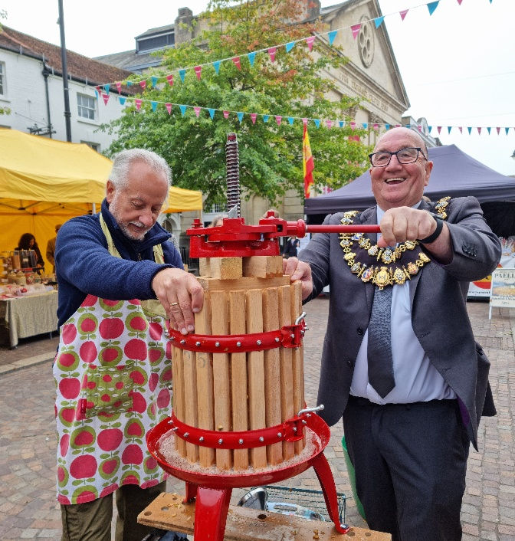
I have also visited care homes, drank many cups of tea, and ate lots of cake. I have engaged with all the many dedicated staff and have met lots of contented residents. Many of our elderly residents are no longer able to look after themselves but do appreciate being well looked after.
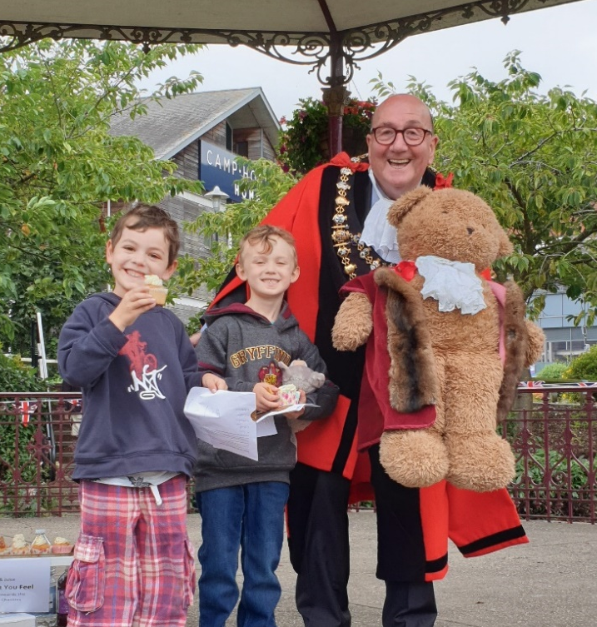
My personal theme and charity for my term people who suffered a stroke. The Mayor’s chosen charity being Speakability, who help people who have recovered from a stroke, like myself, who has recovered from two serious strokes. Here is something I remember from having a stroke from a doctor; one in 6 people will have a stroke in their lifetime, but also one person has a stroke every 5 mins and I am one of 1.3 million stroke survivors. Also like many charities, they have had to adapt to COVID and meet one week on zoom and another at the Chequers Hotel.
There were numerous Civic and Official events during my term. Unfortunately, I missed out on the Mayor’s Drive and Tea Party for our elderly citizens, due to the COVID Pandemic, which my Lady Mayor and I were looking forward to attending and meeting all the over 75s.
I had a fantastic day when I paid a visit to the 40th Anniversary of the Greenham Peace Campaigners at the Control Tower, how the Peace Campaigners have mellowed over the 40 years since they were at Greenham Common.
My wife and I hosted a Teddy Bears Picnic Fundraiser, with lots of children taking part in a teddy bear treasure hunt and enjoying eating all the cakes afterwards.
It gave me great pleasure to present Margaret Gore with her 20th Anniversary certificate to commemorate 20 years’ service a Newbury Town Council.
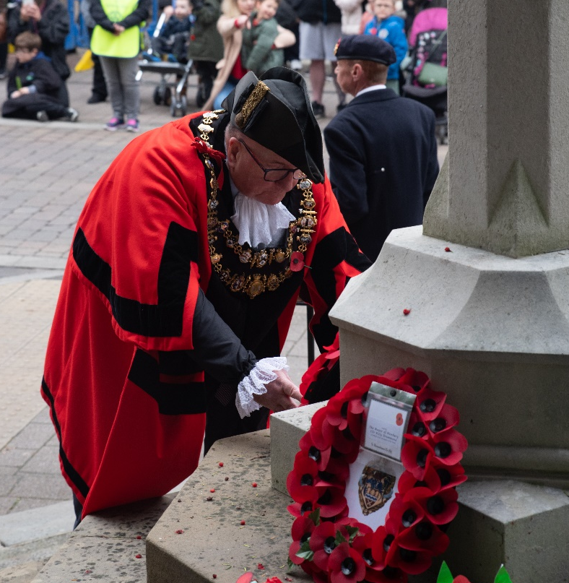
I enjoyed unveiling Blue Plaques to commemorate notable figures from Newbury’s past. These included PC Alexander, who was among the first people to have been given the penicillin injection; and Miss Doris Page MBE, ‘The First Respondent’ who was struck down with respiratory polio as a young mother at 30 and confined for the rest of her life inside an ‘iron lung’. Her journalism under the pen-name Ann Armstrong, and founding the charity ‘Independence at Home’ to help campaign for other disabled people.
I had a great evening handing out certificates to all the winners of Newbury Town Council allotment awards.
Another fond memory was of Sue Campbell, who served 40 years as a volunteer at the Volunteer Centre West Berkshire, that’s what I call dedication!
I will always remember with pride the large number of people who filled the Market Place as I took the salute on Armistice Day Service of Remembrance. I must admit that I had a lump in my throat and a tear in my eye when taking the salute.
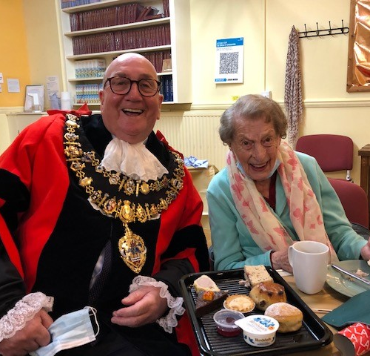
Another great memory was the success of the Local Democracy Week sessions held in the Council Chamber for all the local children who attended and learnt how Newbury Town Council works.
It was also a privilege to ring the bell and open the Michaelmas Fair. I must admit I was rather scared going on the rides!
Another happy memory was switching on the Newbury Christmas Lights, along with the help of Father Christmas and the two Snow Princesses and giving out medals at the Santa Fun Run.
One of the best things about being Mayor is judging the Christmas Card Competition which I hosted with the help of Newbury News. After much deliberation the winner was Ms Victoria Stolyarova who provided my mayoral Christmas card.
One of my most cherished memories was when I hosted a Mayoral Festive Afternoon Tea for more than fifty over 75s at St Nicolas Church, it was truly a great afternoon. Another was the St Nicolas Church Carol Service, followed by a Civic Reception in the Town Hall.
Seeing in the New Year, with St Nicolas Church Bell Ringers, we arrived at 11.45pm and left at 1.30am. We had a wonderful time bringing in the New Year, with nibbles, a drink and great bell ringing. On New Year’s morning I attended a regular event in Newbury’s Town Square, where I met with a great bunch of volunteers from the Newbury Soup Kitchen, where they gave out bacon and egg butties cooked by the chefs at the Vineyard Hotel and 60 mince pies, 30 cheese scones from Angelica’s Terrace Café at Camp Hopson and cups of tea and coffee from the Soup Kitchen.
Helping with the Over 80s parcel fund was another highlight, the people of Newbury are so kind in their giving of time and financial help.
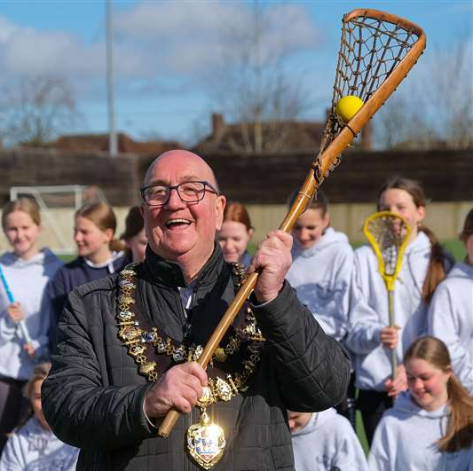
There were visits to various local schools, including Newbury iCollege and one really good memory was of visiting Christ’s Hospital School, in Horsham with Cllr Norman, Elisa Mullen and Ian Campbell. We had a tour of the school and listened to the band playing after lunch.
I had a great morning at the opening of the opening of the newly opened Phoenix Lacrosse Club, at St Bartholomew School.
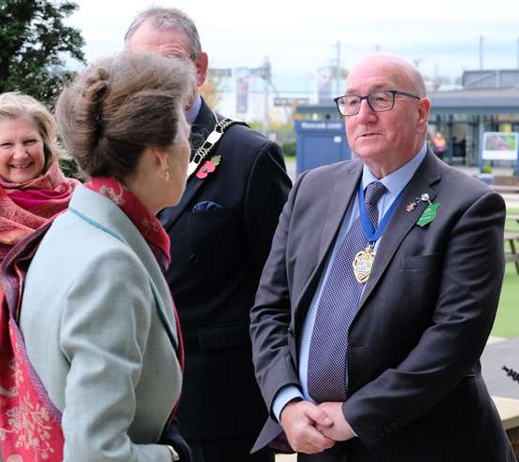
We were fortunate to welcome a group 36 students/teaching staff from Eeklo in Belgium, and I thoroughly enjoyed showing them round the Town Hall. The Mayoress and I have managed to visit Bagnols-sur-Ceze in the South of France with Newbury Twin Town Association, what a wonderful visit!
There were various opportunities to attend functions that represent the Monarch or State. The High Sheriff’s garden party was an opportunity to meet other Berkshire Mayors and various local leaders. The Judicial Service at the Minster Church in Reading marking the start of the Judicial Year.
I also attended a Thanksgiving Service for HRH The Duke of Edinburgh, Prince Phillip, at Reading Minster.
I was invited to the Rifles Biennial Awards Dinner at the Guildhall in London, where her Royal Highness, Duchess of Cornwall; Colonel in Chief of the Rifles and other high-profile guests were present.
I also had the great honour of meeting with HRH Princess Anne at Newbury Racecourse and having lunch.
I had a really good evening at the Newbury Town Civic Awards Ceremony, where I gave out certificates to all the winners and runners-up. I also had the pleasure of being the key speaker at Newbury Town Council’s 25th Anniversary Celebratory Reception. I wish the incoming Mayor all the best with the special anniversary events we have coming up over the next year.
I have had a really good year getting to know Sgt. Josh Lane from Newbury’s ATC 211 Squadron who has been an excellent cadet during my year as Mayor. Long may this practice of having a Mayor’s Cadet continue to flourish for future Mayors, representing the young people of the town.
I would like to thank all the people who have supported, helped at and given so generously to my charities at the fundraising events I’ve hosted this year. These have proven to be a great opportunity to meet and chat with the public in our lovely Town Hall Council Chamber.
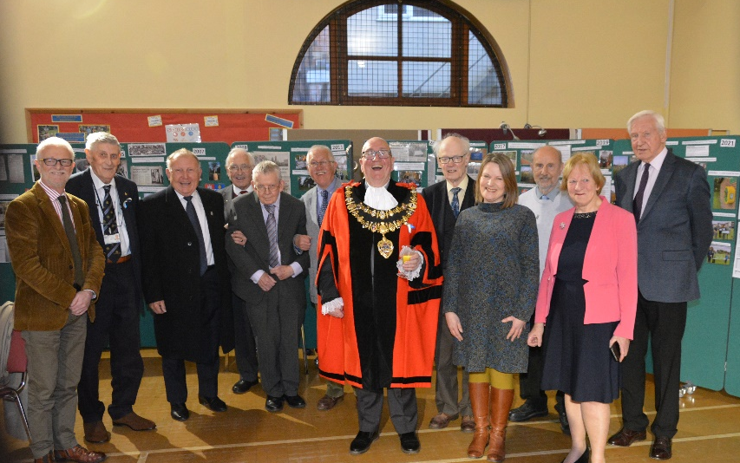
My thanks go to the Mayoress (Sharon Drummond), Civic Manager (Elisa Mullen), Mayor’s Chaplin (Revd Becky Bevan), Mayor’s Attendant (Ian Campbell), the Town Council’s Civic Staff (Barry Digby, Brian Sylvester, Joyce Lewis, Garry Poulson, and Anthony Hewitt), Councillor Gary Norman (Deputy Mayor), Councillors and Officers who have supported me throughout the year.
Newbury Town Council recorded its Thanks to
Councillor Billy Drummond
on behalf of the people of Newbury in recognition of his
Year in Office as Town Mayor
4th May 2021 to 15th May 2022

Present when the Seal of
Newbury Town Council
was affixed

Leader of the Council: Martin Colston

CEO of Newbury Town Council: Hugh Peacocke
Dated 15th May 2022

Town Mayor’s Report to Full Council
22nd June 2021
This is my first report to Council since being elected on the 4th May 2021.

There have been no coffee mornings due to COVID-19, I cannot wait for the restrictions to be lifted.

I won’t subject you all to a detailed report on every event, but there are few things that I think are worthy of specific mention.

On the 14th May I opened Mr Simms Sweet Shop on Northbrook Street, a great place to take the young ones.

On the 19th May I visited the Falkland Grange residential care home, which is part of the Porthaven Care Home Group, which is now carbon neutral. In their bid to become carbon neutral they are supporting an energy project in Indonesia called the Musi River Hydro. They are also supporting a willow tree planting project in the Lake District by planting 800 tree’s (one for every Porthaven resident).

On the 20th May I visited the opening of the Greenham Community Larder, this was to introduce the Community Larder, a variation on the more commonly known food bank model. This is a much-needed initiative in the Greenham area. I expressed much thanks to Greenham Trust, Newbury Town Council, Greenham Parish Council, Eling Trust, and the W E Lawrence Trust as well as private supporters.

On the 21st May CEO Hugh Peacocke, Cllr Jo Day, Cllr Martin Coulson, Cllr Nigel Foot and I met with West Berks MP, Laura Farris for an update on the Town.

On the 22nd May I attended the SEWA UK stall in the Market Place, along with the Deputy Mayor, Cllr Garry Norman. I am sure Cllr Norman will back me up with the quality of the food and the chia.

On the 24th May I opened the revamped outside garden space at the Chequers Hotel. It has been a few years since I have been in but judging from the changes it won’t be long before I am back.

On the 25TH May I had the honour of unveiling a Blue Plague in memory of PC Alexander, a Berkshire boy born and bred and the first person to be treated with penicillin, but sadly died in 1941. Much thanks went to Anthony Pick, chairman of the Heritage Working Group and Brian Sylvester, from Friends of Newtown Road Cemetery for his kind words on Albert. Dave Stubbs, a well-known former Town Marshal, and a former TVP officer, gave a moving speech and two young female PC also attended. And thanks also to Sovereign Housing for allowing the Blue Plaque to go up on Carnarvon building on Andover Road.

On the 29th May I had a great time at CODE NINJAS. It is an ideal place to take youngsters from 5 till 14 years of age to learn about computer programming, it brought out the kid in me. On the way back I called in on the Newbury Lions stall in the Market Place. The Lions are to be too congratulated for all they do in Newbury.

On the 1st June I joined a zoom meeting with the Royal County of Berkshire and Surrey Armed Forces Briefing.

Billy Drummond
Mayor of Newbury

Town Mayor’s Report to Full Council
18th October 2021

Here is my second Newbury Town Council Mayors Report, 18th October 2021.

I won’t bore you all with my report, but I am happy to take questions.

6th June I officially opened the Old Hospital Green’s NHS Commemorative Garden on Andover Road. Caroline and James were in attendance along with two NHS Nurses. On the 4th October, the Royal Horticultural Society has awarded a Pride of Place Award for Old Hospital Green’s NHS Commemorative Garden. A great achievement for all involved. I would like to thank every one of the officers who work at NTC, for all their hard work and dedication in everything they have done during lockdown, in helping keep Newbury Town open.

24th June, Madam Mayor and I attended the meeting about the Newbury Autumn Festival at Donnington Grove golf club.

July 13th I was invited to the British Legion Club for their 100th Anniversary, a day to be proud of all our Armed own.

3rd August I attended a meeting of the Newbury Twin Association.

9TH August I met with my charity, Speakability at the Thatcham Garden Centre for coffee and cake with my Deputy Mayor Cllr Gary Norman, we had a great morning chatting to all of the clients who attend.

14th August it gave me great pleasure to present a 20th Anniversary certificate to Margaret Gore who joined NTC on the 14th August 2001 and has worked tirelessly for the past two decades.

21st August I attended a dedication of specially- planted wood Lockdown Woods to those lost in the Covid-19 pandemic. Three Lockdown Woods have been planted in West Berks to provide spaces for remembrance and reflection.

31st August Madam Mayor and I held a teddy bears picnic treasure hunt competition, organized by Elisa Mullen, the Civic Manager. It started out a bit slow, but after going round the park and rounding up lots of little people, we had a great morning with lots of happy kids.

4th September Cllr Gary Noman attended Reading Pride. He had a fantastic time!

4th September I attended the performance of the St Matthews Passion at St Nicolas Church, which was the first performance of the Newbury Autumn Festival. It was received and good to see that Newbury is coming alive at last.

5th September I was invited to speak to the Greenham Woman’s Peace Protestors, celebrating 40 years since starting out in Cardiff with 35 men, woman and children and walking 120 miles to Greenham. How most of the peace woman have mellowed over the ensuring years.

9th September Madam Mayor and I were invited to a Summer Party at the home of the Lord Lieutenants home in Pangbourne, pity about the weather.

9th September Cllr Gary Norman attended the 60th Anniversary of the Newbury Trefoil Guild, I believe that Cllr Norman felt he was the odd man out!

11th September Madam Mayor and I were invited to the Grand opening of the newly opened Falkland Cricket club. Then I handed out the prizes to the Wash Common Annual Show. I would certainly recommend this event next year, which I do believe will be an annual event, absolutely great day out for all the family.

14th September I had a great evening handing out the awards to all the winners of the Newbury Allotment Awards. I handed out 21 awards, including Best Newcomer, Best Plot, Best School Plot, Best Site Overall and this year’s special award, sponsored by Yew Tree Garden centre in association with Newbury in Bloom was given to one tenant whose allotment plot stood out as the very best across all 6 sites. It went to Sheila Smith, who was presented with a cheque for a £100 in vouchers from Yew Tree Garden Centre.

18th September Newbury Town Hall opened up its door to one and all for the Heritage Open Days Festival. We had many people, young and old through the Town Hall doors. I would like to personally thank officers and Councillors for helping make the day an absolute success.

18th September I was invited to speak to the Newbury Street Pastors. There were 3 new Street Wardens commissioned on the night. Street Wardens do a fantastic job in Newbury by helping the vulnerable and taking some pressure of the police.

28th September I attended the AGM of the Newbury Samaritans.

1st October I attended the opening of the newest restaurant in Newbury, the Blues Smokehouse, it’s great to see new business opening in Newbury.

1st October a great time was had by all at my charity’s quiz night, Speakability and the winning team, led by the Greens won by ½ point. £215 was raised after deductions for food and raffle prizes.

5th October I cut the ribbon on the newly revamped Curry’s store at the retail park.

Cllr Billy Drummond
Mayor of Newbury

Town Mayor’s Report to Full Council
24th January 2022
This is my third report to Full Council.

I won’t subject you all too a detailed report, but I welcome any questions.

There have not been many coffee mornings due to COVID, but hopefully thing will change in 2022.

On the 19th October, I was invited to talk to St John the Evangelists infant School with Cllr Colston and gave a talk about being Mayor of Newbury. I also had a lot of questions from the children.

On the 20th October, we held a Local Democracy Presentation with Falklands Primary and the Willows Schools.

On the 21th October I was invited to the Newbury iCollege Celebrating British Values, Careers and Businesses in the Community.

On 21st October, I was invited to the Licensing Service of the Revd Raymond Obin, at St Marys Church, Shaw.

On the 21st, Cllr Norman Deputised for me at a Local Democracy Presentation with Speenhamland School.

On the 1st November, Cllr Norman, Elisa Mullen and I visited Christ’s Hospital School. We had a tour of the School and after a very nice School lunch we listened to the School band playing, which was excellent.

On the 4th November, we held a Local Democracy Presentation with John Rankin Jr School.

On the 11th November I attended Newbury War Memorial Armistice Service of Remembrance to lay a wreath.

On the 14th November, I felt truly privileged to be part of Service of Remembrance, taking the salute from the service men and women, both active and retired and all others who marched through the town to take part in the service and then on to laying the of many wreaths.

On the 15th November, I attended a service of Remembrance to lay a wreath at RAF Welford.

On the 15th November, Cllr Norman Deputised for me at Louise Purton Toy Appeal at the Newbury Furniture Project.

On the 20th November, I had the privilege of switching on the Newbury Christmas lights, along with the help of the Snow Princesses and Father Christmas, what a great event.

On the 24th November, I attended a celebration for Sue Campbell, who has served for 40 years as a volunteer at the Volunteer Centre. As I have said many times, the people of Newbury are kind both in financially help and in the time they give in volunteering.

On the 24th November, I was a guest at the Guildhall in London at the Rifles Bi-Annual Awards Dinner.

On the 27th November, I hosted a coffee morning for the over 80s parcel fund.

On the 28th November I attended the Santa Fun Run and started the race and gave out medals to the winners.

On the 4th December, I visited the NWN offices for the over 80s parcel distribution day, and helped load up lots of Christmas parcels.

On the 11th December, I hosted a coffee morning for my charity, Speakability.

On the 15th December, I attended the Christmas Tree Festival at St Johns Church, and saw many well decorated trees.

On the 16th December, I hosted a Mayoral Festive Afternoon Tea for the over 75s, in lieu of missing the Mayors Drive, lots of comments and happy faces.

On the 19th December, attended a Christmas Carol Service at St Nicholas Church and Civic Reception in the Town Hall, beautiful singing.

On the 25th December, Cllr Norman Deputised for me at St Georges Church for a Christmas Day Event.

On the 31st I was invited to St Nicolas Church by the bell ringers, to bring in the New Year, really nice bell ringing, finished up with mince pies and a glass of mulled wine.
On the 1st of January, I attended the Newbury Soup Kitchen in the Market Place, where they gave out bacon and egg butties cooked by the Vineyard Hotel, 60 mince pies, 30 cheese scones from Angelica’s Terrace Café, based at Camp Hopson and cups of tea or coffee from the Soup Kitchen who do an excellent job in Newbury.

On the 6th January I opened the new season of exhibitions at the Base in Greenham. The first artist was by Clarke Reynolds, Decoding Braille, Decoding Me. Also, they do a really nice coffee and cake.

On the 20th January, I was invited to St Bartholomew’s School to unveil a Blue Plaque in honour of Miss Jane Esther Luker, the first Headmistress of the Newbury Girls Grammar School, where the School was first opened at the technical institute in Northbrook Street 1904.

Cllr Billy Drummond
Mayor of Newbury

Town Mayor’s Report to Full Council
11th May 2022
On the 6th January I was invited to the Base in Greenham to open an art exhibition, entitled Decoding Braille, Decoding Me. I would encourage all Councillors to visit The Base.

On the 12th January I had an interesting morning visiting the West Berkshire Therapy Centre in Thatcham. They help people who have had a stroke, heart attack or any serious operation get fit again at minimum cost to the client.

On Thursday morning on the 20th January I was invited to unveil the Blue Plaque of Ms Jane Luker. In 1910 the Female-only Newbury County School moved to the Luker site on the Andover Rd. Ms Luker was a formable leader of her day and was well ahead in Woman’s Liberation.
On the 26th January I presented 30 training certificates at the Newbury Community Resource Centre and was also given a tour of all the excellent work that they do in our community.

On the 3rd of February I hosted a visit to the Town Hall from Beenham Primary School and gave them a talk on my role as Mayor and a tour of this historic building.

19th February I was invited to an afternoon crafting by the Newbury Crafters Group and had a great time with the ladies and one gentleman.

I was invited to speak at the Donnington Valley Hotel, to the Newbury Rotary Club. I gave them a talk on the history of the role as Mayor.

On the 27th February attended a Memorial Service to remember all the service men who perished on the HMS Tigris. Brave young men who died for us. We Will Remember Them.

On the 2nd March I spent a pleasant morning at the launch of the Newbury Spring Festival at The Post Barn, Snelsmore Common.

On the 4th March I visited the opening of the Xtrac Acadamy in Thatcham, which specialises in high performance gear boxes to the car racing world. The one thing that surprised me, was that they employed over 380 people.

Also on that evening NTC put up the Ukrainian flag and a candlelight Vigil was held outside the Town Hall and attended by 250 people.

Another highlight of my role on the 12th March, was an invitation to officially open the new Astro Pitch at St Bartholomew’s School. They now have a new name, Phoenix Lacrosse Club. I wish them well and do remember when my two daughters played for the School.

On the same evening I attended at the Newbury Methodists Church to celebrate 10 years of the Newbury Street Pastors.

One of my favourite events was the on the 16th March, when I hosted the Newbury Civic Awards Presentation Evening. My fellow judges and I had a hard job to pick the finalists, but in the end we managed. We are fortunate to have so many talented individuals and groups which makes Newbury a great place to live and work.

On the 25th March at the Trinity School I had a great evening watching a production of Grease, very talented students.

On the 29th March I attended the West Berkshire Junior Music Festival at The Anvil in Basingstoke.

30th March, I hosted a group of students from Eeklo with the teachers in the Council Chamber. I gave them a talk on my role as Mayor and a tour of the historic building and then we had lunch.

I attended on the 31st March at RAF Welford at a memorial service to remember those who died from 101 Squadron. We Will Remember Them.

On 1st April the Town Council celebrated its 25th Anniversary with a special event in St. Nics Hall. Mayors, Councillors and former Council employees attended. It was a fun evening catching up with old friends and a big thank you to the Civic Manager, Elisa Mullen for all her hard work.

2nd April, a night of laughs was had at St Georges Church Hall when I attended a comedy night to raise funds for Parkinson’s UK, a very worthy charity.

On the 30th April I attended a Concert by the South Wales Male Choir, held at St Nics Church, what a great night.

From the 5th May till the 9th May I visited Bagnols-sur-Ceze, one of our twin towns. What a fantastic visit!

I would also like to thank the Deputy Mayor, Councillor Gary Norman, for standing in for me at engagements when I had COVID.

