Councillor Andy Moore

Mayor of Newbury

2024 – 2025

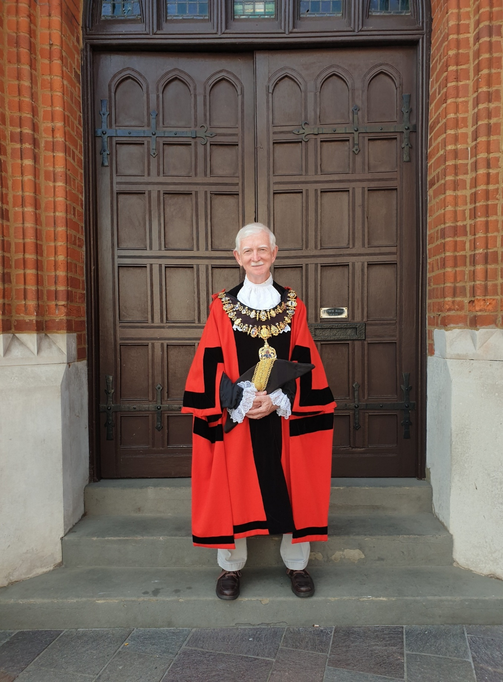

Official Record of Year in Office

12th May 2024 – 11th May 2025

**Date of Mayor Making: 12th May 2024**

**Deputy Mayor:** Cllr David Harman

**Mayoress:** Sheila Moore

**Chaplain:** Rev Will Hunter Smart

**Cadets:** Cpl Milla Brereton and Sgt Thomas Frewing

**Civic Manager:** Elisa Mullen and Joanna Aylott

**Civic Officer:** Amy Xing

**Civic Staff**

Mayor’s Attendant – Gary Poulson

Town Crier – Steve Wallis

Town Marshal – Barry Digby

Mace Bearer – Anthony Hewitt

Mace Bearer – Alan Crame

Mace Bearer – Innes Mason

Mace Bearer – David Risley

Keeper of the Robes – Joyce Lewis

**Mayor’s Chosen Charity**

West Berks Foodbank

**A Taste of the Civic Year 2024 / 2025**

I have been asked a number of times how one becomes Mayor; the answer is with caution and anticipation! Approached by respected colleagues, including several former mayors, I didn’t immediately say “no” but tested the prospect with my wife (to become Lady Mayoress) who would be significantly affected without the background of being on the Town Council. With that green light, I let my name go forward as deputy in 2023 in the expectation that mayoralty would follow – as it did.

At 71, happily enjoying good health, and having lived in Newbury for 50 years, I felt that I could serve our community in this unique role. I have connections in some aspects of Newbury life, but have been surprised at how many others I really knew nothing about. So, I have learned a lot from around 200 times that I was asked either to represent Newbury (for example elsewhere in Berkshire) or to be the face of Newbury in helping to celebrate a significant event; I have made a log of each event with a few words to remind me what took place. I have appreciated the energy that a warm welcome can bring, the conversations that ensue, and I have been thankful that words have flowed when necessary.

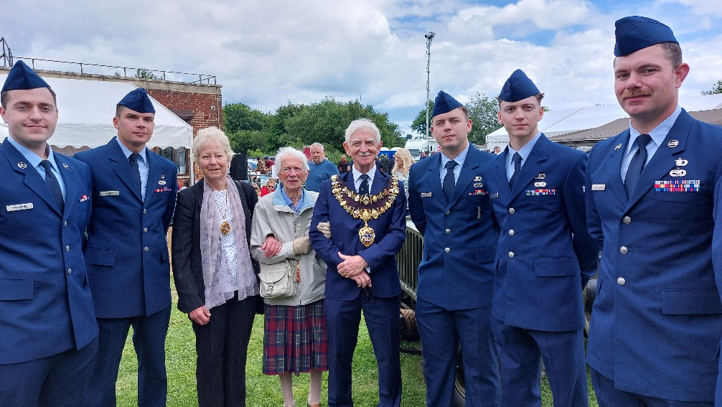Regalia and clothes are an integral part of the Mayor’s existence. Learning about the history of the Chain and being able to name some of the mayors etc. linked to its medallions has been important; people are very interested. I was pleased when the civic team managed to arrange for repair of damaged motto (Floreat Floruit) on the pendant and to get the insurers to pay for it! When not wearing to robes, I felt it proper to be quite formally dressed; I was glad that I hadn’t disposed of suits and ties from my working life – and even a 50-year-old blazer.

The four reports that I have made to Full Council meetings through my year as Mayor follow these words and don’t require repetition, but here are a few thoughts on some categories that I have identified.

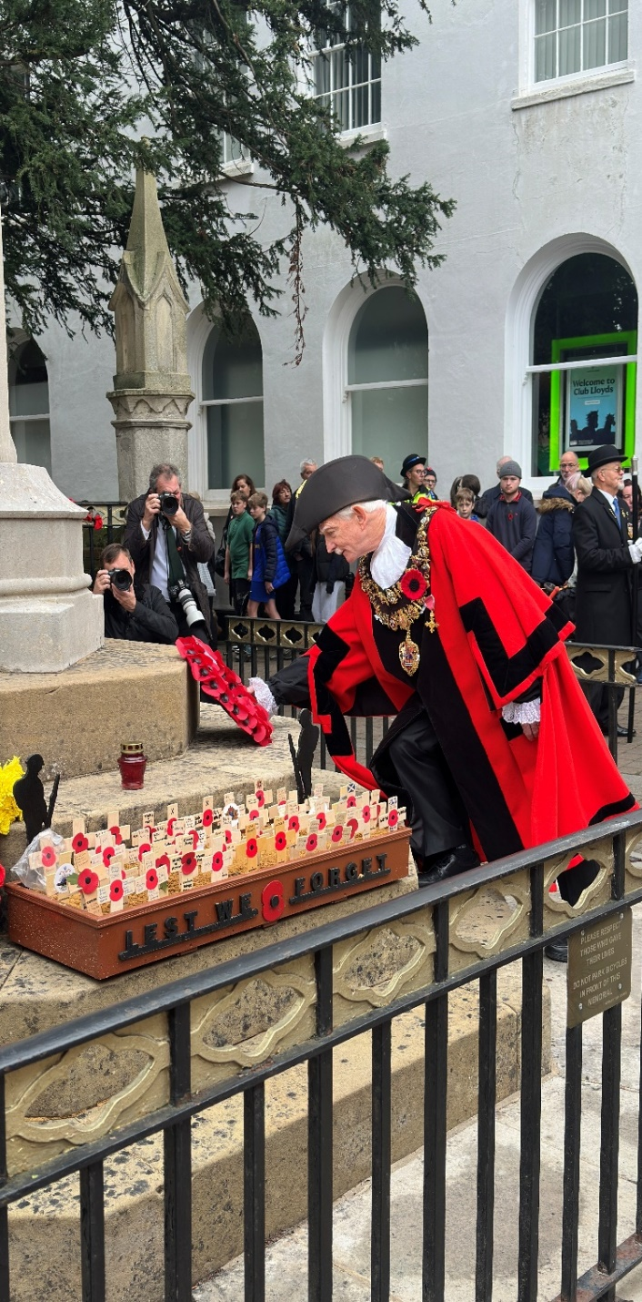During the 1970s and 1980s it felt to me that remembrance had fallen out of fashion. The laying of many wreaths as Mayor at very moving events indicates that our community, and indeed this nation, is firmly back in the habit, and that is very much to be welcomed; we owe so much to those who made such sacrifices.

The performing arts, music, drama and painting/sculpture/photography are thriving in our town and surrounds and standards are incredibly high. Our schools and colleges and other organisations generate enthusiasm amongst the youngsters. Several venues offer opportunities for a huge variety of music; the Symphony Orchestra and Choral Society (and many other choirs) continue with this through all subsequent stages of life. And the professionals grace stages at the Corn Exchange, the Watermill and around the Spring Festival. We are truly blessed.

Changes to our town centre have been to subject of much comment over years and I sense that this will continue. When new businesses do open, it’s therefore a matter for celebration, and I have welcomed invitations to participate. The year can’t pass without mention of that new and much-loved Northbrook Street attraction – Paddington Bear! Adopted as my animal of the year, the Bear has already had a chequered existence, but has put Newbury very firmly in the international media.

I am conscious that on many occasions I am meeting and thanking people who voluntarily, or in their work, are actively making a difference to our community, providing opportunities for our young people, those less fortunate and those at their pastimes. It’s humbling.

Which brings me to the Charity for the year, the first year in which the Mayor’s Benevolent Fund had been solely designated for the charity. I am delighted that Benevolent Fund going forward will attract matched funding from the Good Exchange. It gave me great pleasure to nominate West Berks Foodbank for whom the Lady Mayoress had been volunteering for several years. Working closely with Fran Chamings and Laura Iaschi, we had fun organising coffee mornings, a bingo session, and the Big Gig; what a pity to miss (whilst away in February) the most successful event, and one that we would have particularly enjoyed, the Barn Dance. The total raised was a magnificent £10,050.69 before matching.

None of this would have been possible without significant support from a number of people. My wife, Sheila, having “given permission” has been superb as Lady Mayoress at nearly half my attendances; especially so in engaging the hundreds of people we have met. Garry Poulson, in his first year as Mayor’s attendant, has provided vital support from his extensive knowledge especially of the charitable sector. Jo Aylott (also her first year), Civic Manager, ably assisted by Amy Xing, have made sure I have been in the right place at the right time with the necessary information and support. Sgts Tommy Frewing and Cpl Milla Brewerton have been excellent as my cadets. I would also like to thank Phil Cannings, photographer with the Newbury Weekly News, for ensuring that I came out as best possible in the very many photos that he took.

Newbury Town Council recorded its Thanks to

**Councillor Andy Moore**

on behalf of the people of Newbury in recognition of his

**Year in Office at Town Mayor**

**15th May 2024 to 11th May 2025**

Present when the Seal of

Newbury Town Council

was affixed

Leader of the Council:   
Gary Norman  
  
CEO of Newbury Town Council:   
Toby Miles-Mallowan

Dated 11th May 2025

Town Mayor’s Report to Full Council

24th June 2024

This is my first report to you after some six weeks as Mayor; as at Tuesday last (18 June) I had fulfilled 23 appointments which includes the mayor-making event itself. I am so grateful to all those who contributed to what one former mayor called “the happiest mayor-making”. Particular thanks go to Elisa, master-minding the ceremony for the last time.

A couple of observations from these early days. What a privilege it is to be welcomed to events so profusely; yes, I might have been invited, but to get applause (as on one occasion) just for being announced is heart-warming. Secondly, it has surprised me (even if it should not have) how Newbury’s Mayor is “borrowed” locally. I presented prizes at a Schools Triathlon at Bradfield College, attended Mary Hare’s Sports Appeal launch and was invited to the change of command at RAF (USAF) Welford.

Highlights from the appointments:

· Mock Trials Regional Final (Reading Crown Court) with Trinity School coming second;

· Newbury Spring Festival: Graffiti Classics at Winchcombe School, and the final concert in St Nic’s – “extended” to include Cold Ash Brass and Wantage Band also in St Nic’s;

· Starting the Newbury 10k Race (less painful than running in it as I have previously done!);

· The D-Day 80 commemorations at the Greenham Control Tower.

The Deputy Mayor reports enjoying Thatcham’s Mayor-making immediately following ours and his visits to Good Vibes Music Academy (during the Spring Festival) and Castle School’s Art Event at the Discovery Centre.  
  
Cllr Andy Moore, Mayor of Newbury

Town Mayor’s Report to Full Council

21st October 2024

Since my report to the June meeting, I have attended a further 59 events (to 12 October) where the Mayor has been requested and I have been delighted to go; at a large proportion of those I have been accompanied by the Lady Mayoress. There has been a huge variety, but some categories can be identified.

**Concerts**

Rotary put on the Mayor’s Concert at the Corn Exchange; the MC was a former Mayor and there was an eclectic mix of acts including that by another former Mayor. The same MC was at Ace Space to celebrate VCWB’s 50th anniversary, and the Symphony Orchestra performed with a nautical theme in St Bart’s Hub which included a world premier by 16-year-old Charlotte Robertson.

**Sports**

Yoga at the Bandstand with the realisation that I should have started this activity well before being 70! Boules in Market Place organised by Rotary for good local causes, with a very flukey opening throw; two months later leading the NTC team to their annual thrashing by Newbury Bowls Club followed by a pleasant social. We were no better at cricket; the NTC team made an early exit from the competition well hosted by Falkland Cricket Club and organised by Community United on a beautiful September day.

**Openings and Unveilings**

Three openings in a single morning in central Newbury: Tracey James Hearing in Wharf Street; Homestart Babybank in new premises in Broadway House and Gail’s Café just across from the Town Hall. We joined Newbury Methodist Church to celebrate the opening of the reworked garden with possibly the world’s largest Methodist Cross at its centre. At Theale Green School, I unveiled a purple plaque celebrating the inspiring story of former pupil Laura Baylis (from a family with Newbury connections). At Bills the blue plaque marking the former Plaza couldn’t be “veiled” but was “opened”; many thanks to the Heritage WG and local historians. More recently, the paparazzi were in town as I was surprised to reveal that Paddington had taken up residence on a bench in Northbrook Street.

**Presentations**

The autumn season brought requests to present the work of NTC and the Mayor: to a Men’s breakfast hosted by Thatcham churches; at dinner with the Rotary Club and to a morning assembly at St Gabriel’s School. We are currently in the midst of our Local Democracy offering with primary classes crocodiling in; many thanks to Jo Day and all those taking part.

**Arts**

To a non-artist, the end of term art exhibitions at Trinity School and Newbury College revealed wonderful variety and imagination, and that clearly carries on in later life as was evident at Art-on-the-Park in August. It was good to celebrate the 50th anniversary of the Arts Society Newbury, followed up by tea and conversation with its chair and a fascinating lecture on Banksy.  
  
**Horticulture**

The immense amount of hard work that goes into gardens and planting across our community was marked with the Newbury in Bloom awards; judging and organising that is an equal labour, but clearly done with love: congratulations to the Growing Newbury Green Group. After squeezing apples in the Market Place, we went to Wash Common allotments to celebrate harvest and receive gifts for the Foodbank.

**More formally**

What an honour to wear the Mayor’s chain at the funeral of Jeff Beck (a former wearer) and celebration of his life of service. I also wrote to the family of Val Bull (former Mayor) who died in July but requested no funeral. We marked the 60th anniversary of Twinning with Braunfels with a pleasant ceremony in the chamber. A few days ago, the beginning of the Judicial Year was marked by a service in Reading Minster attended by Mayors from across the county among many others led by the High Sheriff.

**Mayor’s Charity**

We have held two coffee mornings and a bingo night with West Berks Foodbank, and plans are in hand for Carols in the Dolphin, a Burn’s Night Barn Dance and a reprise of last year’s gig featuring similar bands. The support of the civic team for these events has been excellent, and so far, they have ensured that I have arrived at the right time and place with briefing on all occasions.

**Deputy Mayor**

David has attended AGMs for the Patient Information Point (at the Community Hospital) for Citizen’s Advice (who will be with us at this meeting). He awarded prizes at Sports Personality of the Year for Trinity School and celebrated Matildos Lithuanian School’s first year at Horris Hill School. He represented Newbury as the USAF marked its 77th anniversary at RAF Fairford, and most recently has been to the Mosque Open Day at the West Berkshire Muslim Centre’s base at Riverside.

Cllr Andy Moore, Mayor of Newbury

Town Mayor’s Report to Full Council

27th January 2025

The period from my last report in October to now (17 January) always promised to be the busiest, and so it proved with a further of 76 events which I was delighted to attend. This is too many to report individually, but here are some themes.

**Schools**

Very ably organised by Jo Aylott and Jo Day, primary school visits to the Town Hall continued with the Mayor in full rig spinning some yarns in his parlour! I was pleased to attend assembly at St Nic’s Junior school (40 years of memories and personal connections) and present School Council badges to two pupils from each year. Just recently the i-College extended an invitation to its Year 11 prize-giving: a brief event full of support and celebration.

**Bears**

Following the Paddington moment (last report), there were Marmalade Cocktails at the opening of the new Coat & Bear hotel/restaurant in Bartholomew Street and subsequently a short spell in the Pudsey Bear suit in aid of the BBC Children in Need appeal run by Rotary. My animal of the year!

**Remembrance**

As former mayors suggested, taking the salute at the Remembrance Sunday ceremony was a big moment half-way through my year. We gathered again on Armistice Day around the War Memorial, and in the previous week had been at RAF Welford with the USAF. The US theme continued at the Greenham Control Tower on 12 Dec – the 80th anniversary of two tragic USAF accidents. On 15 Dec we marked the 10th anniversary of the end British combat operations in Afghanistan also at the War Memorial. Newbury Pride showed a film to mark Transgender Day of Remembrance. We celebrated UN Day on 25 Oct and marked UN Solidarity with Palestine on 29 Nov.

**Art & Performance**

Students from 16 local schools and colleges had work on display at the Base Gallery earlier this month. The Spring Festival invited us to Sunday with Sondheim to showcase an item coming in this year’s programme. Kingsclere Performing Arts College (an associate of Newbury College) put on a high-quality show in Basingstoke, and the Wantage Band played live the accompaniment to The Snowman film. It was a privilege to have front-row seats to see Mathilde Milwidsky play the Mendelssohn violin concerto at NSO’s autumn concert.

**Pre-Christmas**

It almost felt that the festive season began with the Michaelmas Fair at which the Mayor’s Cadets were pressed into service on the scariest rides. A month later it definitely had, with the Christmas lights to be switched on after a tour of the many market stalls: a huge crowd in the Market Place and beyond. Thereabouts was the start of NWN’s Parcels campaign.

Cllr Andy Moore, Mayor of Newbury

Town Mayor’s Report to Full Council

7th May 2025

This will be my last report to Full Council as Mayor. Since it is written in time for the meeting (28 Apr), it won’t quite cover everything I will have done – my final Saturday promises to be particularly busy – but I can report on 43 further engagements which I have grouped together below. Special thanks to Jo Aylott for organising the repair of the Mayor’s pendant and to the Deputy Mayor for the loan of his on a couple of occasions while this was being done.

**Openings**

Four “ribbon & scissors” occasions: the beautifully restored Rectory Clinic at Toomers Wharf (dentistry and more); Hayes Travel in Northbrook Street with an enthusiastic saxophonist; Primark in Park Way with 90 new staff, a large crowd and a lot of razzamatazz and most recently KütchenHaus in the Market Place. In their own way, each business had a story to tell; it is good to welcome them to our town.

**Overseas**

The Coffee Morning and AGM of the Twin Towns Association, whilst both in the Chamber, did draw attention to our European twin towns. Entirely unexpectedly, I was a guest lecturer at the Gandhigram Institute in Tamil Nadu, India! During a visit for our charity (the Miriam Dean Fund – Newbury-based), it got out that I was Mayor, and this prompted the invitation.

**Food**

Passing by the EKO Café in Bartholomew Street to a talk to Friends Together in St Nic’s, we were invited to “breakfast” – a few days later; we were served with a Turkish celebratory feast – they know how to celebrate! The Lady Mayoress and I managed parts of two Iftar meals due to a small muddle at the Riverside Centre! We were a little more organised for dinner in the Officer’s Mess at Hermitage; the guests included a 101-year-old veteran of the Chindits. A Mayor’s Coffee Morning was the last event for the Benevolent Fund in support of the West Berks Foodbank.

**Music & Drama**

Incredible variety here: opening with the play in the Chamber about the inquiry leading to the Newtown Road Cemetery, starring members of the Civic Team. The Mayor’s Big Gig had variety within it – four great local acts – and the following evening the Newbury Symphony Orchestra entertained with two favourite pieces. Trinity School did Charlie & the Chocolate Factory, Newbury YoungStars performed Sister Act, and the Berkshire Music Trust put on two concerts with music from films in the Hexagon: primary schools choirs and the excellent Wind and Symphony Orchestras.

**Remembrance**

Holocaust Memorial Day was marked in WBC’s foyer and with the flying of the UN Flag from the Town Hall. A pilgrimage on behalf of the Palestinian people was met as it passed through Newbury towards London. At RAF Welford the loss of a Wellington Bomber in March 1944 (crew 4xRAF, 2xRAAF, 2xRCAF) was remembered by a substantial gathering including relatives from overseas.

**Awards**

A recent invitation was to be guest speaker as the West Berkshire cohort of Thames Valley Police presented awards at their splendid Sulhampstead Training Centre. It was good to be welcomed by former town marshal and PC, Dave Stubbs, and to view “his” museum. The service given by all who received awards was universally awe-inspiring; we owe a huge debt to those who keep our community safe.

**Paddington**

The events of the early hours of 2 March have received massive publicity. I did radio and TV interviews on the Monday morning and was asked to comment again when the perpetrators were sentenced. The “resurrection” ceremony was a bigger affair than the original unveiling in October and, rightly, BID members did the honours.

**Deputy**

13th February - represented NTC at Trinity School's House ADT Competition. A very high standard of exhibits was on display from student's GCSE, AS and A Level course work.

15th February - attended a West Berks Food Bank promoted Barn Dance at St. George's Hall, Wash Common. A great time was had by all, with much enthusiastic participation, with funds being raised in support of this vital local charity.

22nd March - Further to invitation by The High Sheriff of the Royal County of Berkshire, represented NTC at the Magistrates' Court Mock Trial Competition at Reading Crown Court. 10 Berkshire secondary schools competed in the mock trials, including Trinity School, taking turns at defence and prosecution, with students performing as barristers, witnesses, the accused, court officials and supporting magistrates as jurors. The standard was very high, I'm sure a few budding barristers have been discovered!

25th March - represented NTC at Diamond Quality Care's Open Day at Greenham Business Park. Diamond Care provide support and encouragement to adults with acquired physical disabilities, neurological conditions and acquired brain injuries. During the Open Day they displayed the wide range of activities at their enablement centre and showcased arts and crafts, cooking skills, woodwork, their gym facilities, pool, and sensory room. It was a please to meet the staff and their clients.

4th April - attended Hungerford Town Mayor's reception, hosted by Hungerford Town Council at The Royal British Legion in Hungerford. Hungerford's Mayor Simpson led the event, with thanks to staff, Cllrs and the local community for the last year's mayoral term.

5th April - represented NTC, presenting Newbury District Primary Schools Football Association with the winners’ cup for the Cotswold league, a huge achievement, this being the first time the title has been held by Newbury DPSFA in the 57-year history of the club.

5th April - attended Beenham Wind Orchestra's 'Lights, Camera, Action' event at St. Nicolas Church. It was a delightful event, with musical performances of well-known film scores, at a very high standard.

12th April - represented NTC at The West Berks Indoor Bowls Club, for presentation of the West Berks Shield at the culmination of the strongly fought bowls competition.

22nd April - attended United Nations Association Newbury Branch's AGM. AGM matters were discussed, plus presentations from P. Glover on Green Fest / West Berks Green Exchange, plus H. Shono, new Chair of UNA Conference Committee. Highlighted upcoming events were 22 May UN Peacekeepers Day, and 25 June Volunteer Centre event at Shaw House.

Cllr Andy Moore, Mayor of Newbury