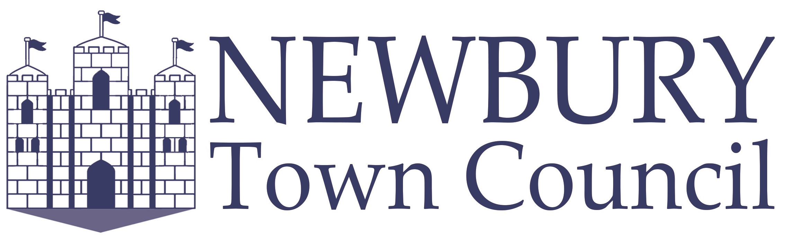

THE NEWBURY TOWN COUNCIL CIVIC AWARDS 2022 NOMINATION FORM

We continue to ask for nominations of people in Newbury who work extremely hard in a voluntary capacity for the benefit of our local community. For 2022, we have four awards available: The Newbury Town Civic Award, The Newbury Town Young Persons Civic Award, Newbury Town Civic Award for Business, and The Newbury Town Civic Award for Environmental Impact. Please ensure you read all the information to make sure your nomination is eligible to be submitted.

The Newbury Town Civic Award
This person does not have to live within Newbury Town; however, their voluntary activities should be predominantly within Newbury Town or benefit the town.

The Newbury Town Young Persons Civic Award
This person must be age 21 or under. They don’t have to live in Newbury Town; however, their voluntary activities should be predominantly within Newbury Town or for the benefit of the town.

The Newbury Town Business Civic Award
The Town Council wants to acknowledge the contributions made by the many businesses who are giving something back to the community in Newbury. This could be through employees volunteering for local causes, through fundraising or contributions, or by partnering with local charities and organisations. The business does not have to be located within Newbury Town; however, the contribution or volunteering activities should be predominantly within the town or for the benefit of the town.

The Newbury Town Environmental Contribution Civic Award
The Town Council wants to acknowledge the contributions made by individuals and organisations whose volunteering impacts the local environment by helping to reduce CO2 emissions, or to reduce/recycle more waste, or to increase biodiversity. This could be through conservation projects, green initiatives, fundraising, or by awareness raising. The individuals or organisations do not have to be located within Newbury Town, however their contribution or volunteering activities should be predominantly within Newbury Town or for the benefit of the town.

A presentation of the Awards will take on Wednesday 16th March 2022 at Town Hall Council Chamber where all nominees will be invited to attend.

Please compete and return the form no later than Sunday 20th February 2022.

Please select which award you would like to nominate this person/organisation for (only one award per nominee):

- The Newbury Town Civic Award
- The Newbury Town Young Persons Civic Award
- The Newbury Town Business Civic Award
- The Newbury Town Environmental Contribution Civic Award

Nominees Name
Age (for Young Persons Award only)
Address
Tel No
Email Address

Reason for Nomination: (please provide as much information as you can about why we should consider this person/organisation for the Award, and why they are special. You may continue on another page of A4 if you wish.) These questions may support you in your submission; what is the voluntary role that is carried out? / How long have they been volunteering? / How often do they volunteer? / What or who benefits from what they do? What makes this person stand out from everybody else? / Any further information that may support your nomination.

Nominated By:
Name
Address
Tel No
Email
Organisation (if any)
Signature
(e-signatures accepted)
Date

Please return to the email or postal address below no later than Sunday 20th February 2022. Announcement of the Awards will take place on Wednesday 16th March 2022.


All data collected will be used for the purpose of The Newbury Town Civic Award and unless requested and approved for publicity purpose will be destroyed within 30 days of the 16th March.

